Regional Review of Development Policy Interventions in Key Agricultural Commodity Sectors in non-ACP African Developing Countries

Final Document

16 June 2008

Marian Garcia

Marian Garcia (M.Garcia@kent.ac.uk) is Senior Lecturer at the Kent Business School, University of Kent, UK.

Table of Contents
1 INTRODUCTION 6
2 EGYPT HORTICULTURAL SECTOR 9
2.1 Introduction 9
2.2 Factors Influencing Policy Interventions in Egypt’s Horticultural Sector 10
2.2.1 Internal Factors 10
2.2.2 External Factors 12
2.3 The Horticulture Export Improvement Association (HEIA): Linking Producers to Markets 13
2.3.1 Impact on Egypt’s Horticultural Exports 14
2.3.2 Lessons Learnt 16
2.4 Citrus Improvement Program: Multi-Stakeholder Approach to Intervention 16
2.4.1 Project Approach to Intervention: 19
2.4.2 Project Impact 19
2.4.3 Lessons Learnt 20
2.5 Conclusions 21
3 TUNISIA OLIVE OIL SECTOR 22
3.1 Introduction 22
3.2 Factors Influencing Policy Interventions in Tunisian Olive Oil Sector 25
3.2.1 Internal Factors 25
3.2.2 External Factors 27
3.3 Policy Interventions to Revitalise Tunisian Olive Oil Exports 30
3.3.1 National Programme to Promote Packaged Olive Oil Exports 30
3.3.2 Promotion of Organic Olive Production 31
3.4 Conclusions 32
4 FRESH CUT HERBS IN JORDAN 32
4.1 Introduction 32
4.2 Factor Influencing Policy Interventions in Jordan’s Agricultural Sector 32
4.2.1 Internal Factors 32
4.2.2 External Factors 32
4.3 The Conservation of Medicinal and Herbal Plans of Jordan Project 32
4.3.1 Providing Awareness and Specific Training to Beneficiaries 32
4.3.2 Providing Initial Technical Support and Promotions 32
4.3.3 Establishing Linkages Between Actors in the Chain 32
4.3.4 Project Impact 32
4.4 Conclusion 32
5 THE HAZELNUT SECTOR IN TURKEY 32
5.1 Introduction 32
5.2 Factors Influencing Policy Intervention in Turkey’s Hazelnut Sector 32
5.2.1 Internal Factors 32
5.3 The Agricultural Reform Implementation Program 32
5.3.1 The Direct Income Support System 32
5.3.2 The Farmer Transition Program 32
5.3.3 The Restructuring of the Agricultural Sales Cooperatives and Cooperative Unions 32
5.3.4 The Public Information Campaign 32
5.4 Conclusions 32
6 Morocco Agricultural Sector 32
6.1 Introduction 32
6.2 Factors Influencing Policy Intervention in Moroccan Agricultural Sector 32
6.2.1 Internal Factors 32
6.2.2 External Factors 32
6.3 The Integrated Agriculture and Agribusiness Program 32
6.3.1 Program Activities 32
6.3.2 Project Impact 32
7 Conclusions 32
8 References 32
Appendix 1: Export of HEIA Crops Compared to Other Egypt’s Horticultural and Agricultural Exports 32
Appendix 2: Agricultural Offers to Egypt, Preferences in 1997-2004 and EU/Egypt Association Agreement 32

List of Tables
Table 1. Egypt’s land area and population 10
Table 2. Egypt horticultural exports before and after the creation of HEIA 15
Table 3. Citrus Improvement Program (CIP) impact 20
Table 4. Contribution of the private sector to Tunisian total olive oil exports, 1995-2002 (‘000 tons) 23
Table 5. Average Tunisian Olive Oil Production, 1990-2002 25
Table 6. Tunisia share in the European market of olive oil according to the qualities, 1990-2001 (%) 27
Table 7. Evolution of olive oil import in USA, Canada, Japan and Australia (ton) 27
Table 8. Equivalent Tariff and Alert Price for Olive Oil (Euros/ton) 28
Table 9. Intervention price for the storage and the olive oil importation 28
Table 10. Distribution of the budgetary envelope according to member countries 30
Table 11. Evolution of Tunisia’s organic agricultural area, 1997-2001 (ha) 31
Table 12. Production and exports of Tunisia’s main organic crops (Tm) 32
Table 13. Jordan’s main trade partners, 2005 32
Table 14. Fresh herbs traded at main wholesale markets in Jordan, 1997-2004 (tons) 32
Table 15. Herb exports to Arab and non-Arab (EU) countries, 1997 - 2004 (tons) 32
Table 16. Returns to water use in the MENA region, by crop 32
Table 17. Similarities and differences in the pattern of intervention and their relative level of success. 32

List of Figures
Figure 1. Egypt’s citrus cultivation areas, 1995 – 2004 (ha) 17
Figure 2. Egypt’s citrus production and exports, 1995 – 2004 (Million tons) 17
Figure 3. Ratio of Tunisian olive oil export earnings to olive production, 1961-2004 (US$) 22
Figure 4. Evolution of Tunisian olive oil exports to the European market, 1991-2005 24
Figure 5. Evolution of Olives Production in Tunisia, 1991-2005 26
Figure 6. World hazelnut production, 1961-2002 32
Figure 7. Hazelnut cultivation area in Turkey 32
Figure 8. Hazelnut yields in Turkey 32
Figure 9. Development of Turkish hazelnut export and export prices 32
Figure 10. Purchase shares of FISKOBIRLIK 32
Figure 11. Hazelnut production costs and purchase price by FISKOBIRLIK 32
Figure 12. Hazelnut cultivation areas and production in Turkey 32
Figure 13. Hazelnut stocks of FISKOBIRLIK 32
Figure 14. Labour requirements of Moroccan agriculture 32

INTRODUCTION
This review aims to inform the baseline information screening process of the EU-CAP All Agricultural Commodities Programme by focusing on successes and limitations of different policy interventions along the supply chain in a selected number of developing Mediterranean countries. The objective is to generate insights on best practice in selected countries that can be used to inform the process of commodity chain diagnosis and strategy formulation in the selected ACP countries, by identifying policy interventions that have been particularly successful in promoting commodity chain development.

The document presents detailed case studies of policy interventions in support of agro-industrial development in five developing Mediterranean countries: Egypt, Tunisia, Jordan, Turkey and Morocco. For each country, the case studies document specific intervention policies adopted in key agricultural sectors and examine the impact of these interventions on relevant stakeholders. The case studies selected for the analysis represent key commodity groups for the respective countries in terms of export earnings and potential impact on poverty alleviation and regional development. Cases capture variations regarding institutional arrangements, intervention approach, overall investment requirements, and risk and limitations. Case studies were developed primarily based secondary information gathered from various sources, including academic journals and gray literature. In addition, primary information on the specific intervention initiatives covered by the review was gathered through discussions with international donors and development banks operating in the region.

In documenting the strategies, the document has reviewed both internal (i.e., water and land reclamation, marketing structures, logistic and infrastructure) and external (i.e., trade agreements, liberalisation of markets, global sourcing) factors influencing policy interventions. Specific development initiatives in the selected countries are then reviewed, with particular focus on: (i) intervention drivers, (ii) intervention objectives, (iii) intervention approach, and (iv) intervention impact. The case studies provide a clear indication of the sequencing of policy interventions, with special emphasis on the institutional arrangements and financial and technical support provided by the international donor community and development bank institutions. Recommendations are drawn from critical analysis of the impact of reviewed intervention policies on agricultural development and poverty alleviation. By comparing intervention approaches across countries, the study aims to identify key insights on best practices on interventions to promote agro-industrial development. There are a number of success and/or failure factors common to all development initiatives across all reviewed countries while others tend to be sector specific.

Value chain analyses have not elucidated thoroughly the nature of the linkage between successful value chain developments and the level of producer assets (farm or business size factor) and entrepreneurism (market-oriented culture). Certain value chains may be successful because they target already better endowed producers; in other cases, financial and technical assistance may build the asset endowments of poor producers and lead to differentiation. The implications for intervention strategies may be different depending on the causality underlying the correlation, and are likely to affect the attractiveness of private and public sector involvement.

The following case studies have been included in the study:

Egypt: horticultural sector
Egypt has a broad-based and highly diversified horticultural sector mainly supplying its domestic market. Only 3.5% of the country’s horticultural production is exported (Alaa, 2004). However, substantial potential exists for the further diversification into high-value horticultural crops of improved quality, considering their potential for income and employment effects for farmers and landless rural workers. Its soils, climate, location in the Middle East, and close proximity to Europe put Egypt in a strong competitive advantage in regional horticultural exports to European markets. The report provides an overview of two policy interventions that have been particularly successful in expanding the production and export capacity of Egypt’s horticultural sector: the Horticulture Export Improvement Association (HEIA) and the Citrus Improvement Program (CIP).

Tunisia: olive oil
Tunisia is the world’s second larger olive oil producer after the EU; however exports consists of the lowest grade of virgin oil, the lampante olive oil. Moreover, 99% of Tunisian olive oil exports to the EU involved entreated oil in bulk, which deprives Tunisian exporters of the value added associated with refining, packaging, marketing and product identity. The sector has witnessed an incredible revolution since 1994. This has corresponded with the abolition of the monopoly on olive oil exports formerly retained by the state-controlled Office Nationale de l’Huile (ONH). The private sector responded to the opening up of the market and the ratio of olive oil export earnings to olive production hit new levels after 1994. The document provides an overview of initiatives aimed at revitalizing Tunisian olive oil exports. The document focuses on two government interventions: the National Program to Promote Packaged Olive Oil Exports aims to increase the percentage of olive oil that is conditioned in Tunisia (with a Tunisian brand) in order to add value to the final product rather than the traditional export policy of selling in bulk. The second policy intervention aims at promoting organic olive production hence Tunisia’s olive oil sector can take advantage of increasing international demand for organic agri-food products. Both cases illustrate how the public sector can support the private sector to become more competitive and take advantages of increasing international marketing opportunities.

Jordan: medicinal and fresh cut herbs
The agricultural sector started to witness declining growth rates during the late 1990s. This decline was attributed to the policy of trade liberalization adopted by the government in 1994, and to the Structural Adjustment Program of the Agricultural Sector (ASAL) in 2000. This trend increased with the implementation of measures related to Jordan’s accession to the WTO, where measures undertaken for the protection of local production from external competition where abolished, except for a small percentage of custom duties on the import of certain commodities. Subsidies have been totally lifted and national agricultural products have had to compete with imported goods in the domestic and export markets. These developments coincided with a decline in the quality and quantity of water available for irrigation, which affected crop productivity and quality of produce and its competitiveness, in quality and price, in domestic and export markets. Medicinal herbs and aromatic plants possess higher water use efficiency, relatively higher economic returns per unit area compared to conventional crops, and the potential to add value through processing and marketing. Moreover, there is increasing demand for fresh herbs both domestically and international. Jordan’s unique climate and diverse agro-ecosystems allows medicinal herbs and aromatic plants production on large and small-scales all year round. The report provides an overview of the development policy and institutional interventions to promote medicinal herbs and aromatic plants production in Jordan and the implementation results of the Conservation of Medical and Herbal Plants of Jordan project to date.

Turkey: hazelnuts
Turkey is the world’s largest hazelnut producer, accounting for about 74% of the world’s production (625,000 metric tons) in 2002. Due to the economic and social importance of hazelnut production in Turkey, the government provided price support and guaranteed purchases between 1964-2000. As a result of government intervention hazelnut prices increased, resulting in a large expansion of hazelnut cultivation areas with significant amounts of surplus product and stock accumulation. To control the accumulation of stocks, restrictions on hazelnut-planted areas have been implemented; however they have been ineffective in reducing plantation areas. Turkey embarked on an ongoing structural adjustment and stabilization program towards the end of 1999. To reduce inflation and in accordance with the International Monetary Fund (IMF) commitments, the government prepared the Agricultural Reform Implementation Program (ARIP) financed by the World Bank. The aim of the ARIP is to reduce artificial incentives and governmental subsidies and to gradually convert the present support policies to direct income payments. The report examines the implementation of the ARIP in the hazelnut sector and explains the effects policy interventions are having.

Morocco: agricultural sector
Agriculture (including fishing) accounts for 14% of Morocco’s GDP (2006), provides 40% of total jobs, and accounts for almost all employment in rural areas, where half the country’s population lives. Agriculture represents around one-fifth of exports, yet the export potential is by all accounts insufficiently exploited, and imports are growing as tariffs fall. The report provides an overview of an USAID funded project, the Integrated Agricultural and Agribusiness Project, aimed at increase the global competitiveness of Morocco’s agricultural sector through activities in agricultural policy and institutional development, production and processing of agricultural products and the development of support services.

EGYPT HORTICULTURAL SECTOR

Introduction
Agriculture represents a key sector for socio-economic development in Egypt. It accounts for around 18% of Egypt's gross domestic product (GDP), employs more than 33% of the labour force and provides about 20% of the country's exports (FAO, 2005). Future growth of the agricultural sector and its contribution to income, employment and poverty alleviation will have to come mostly from a more efficient use of water and land resources. Substantial potential exists as well for the further diversification into high-value horticultural crops of improved quality, considering their potential for income and employment effects for farmers and landless rural workers. Its soils, climate, location in the Middle East, and close proximity to Europe put Egypt in a strong competitive advantage in regional horticultural exports to European markets.

However, achieving this potential requires significant improvements in the quality of exported horticultural produce, high quality packing and packaging, advanced post harvest handling procedures, compliance with EU regulations and requirements, sustainable supply of demanded products to importers in the destination markets and keep up with the dynamic changes in consumption patterns in the EU markets in terms of new products, new varieties, and the continuous changes in regulations and requirements.

Egypt has a broad-based and highly diversified horticultural sector mainly supplying its domestic market. Only 3.5% of the country’s horticultural production is exported (Alaa, 2004). Egypt has the potential to become an exporter of tomatoes, cucumbers and peppers; however will face strong price competition from Spanish producers during the winter period (Wijnands, 2004). They have the opportunity to produce a guaranteed quality level with which they can maximize the market windows with a quality product in periods of limited supplies and thus compete with Spain (Muaz et al., 2004). The reform of the Egyptian economy is in full progress and the EU/Egypt Association Agreement will contribute to an increase in trade between the EU and Egypt (see section below). Some signs of this increase are reflected in the export growth of, for example, strawberries and seedless grapes (see Appendix 1). Success in entering EU markets will lie in meeting EU quality and safety standards and requirements and reaching appropriate market channels. Currently, only a very small number of Egyptian producers/exporters are pursuing these factors. Consequently, improvements in the use of grades and standards, especially sorting by size, quality, and condition are required.

The objective of this chapter is to provide an overview of policy interventions in support of Egypt’s horticultural sector development. The document focuses two interventions that have been particularly successful in expanding the production and export capacity of Egypt’s horticultural sector: the Horticulture Export Improvement Association (HEIA) and the Citrus Improvement Program (CIP).

Factors Influencing Policy Interventions in Egypt’s Horticultural Sector

Internal Factors
- Water and Land Reclamation
Water resources in Egypt are deemed to be limited when compared with the rate of population growth that is increasing continuously. The agricultural sector is Egypt's largest consumer of water, using about 85% of the country's surface water resources (Wijnands, 2004). A network of about 30,000 km of irrigation canals and 17,500 km of drainage channels serves the estimated 3.1 million ha of irrigated land in Egypt, which represents only 3% of the country's total land area. To alleviate pressure both on the Nile water and on old agricultural land, the government has initiated various strategic programs. These projects will have major impact on the water balance of the Nile Delta.

Land scarcity is reflected in the four fold increase in land rent since the liberalization of land rent in 1997. To address this issue, the government launched a major program of land reclamation in the Western Delta through the Nasser Canal, the Eastern Delta, and Sinai (Es Salam Canal), and more recently in the South of the New Valley (Toshka) and East Owaynat on the borders with Sudan. This program in its first phase is planned to add about 1.3 million feddan to the cultivated area in Egypt and other 2.5 million feddans more by 2017.

- Egypt’s land area and population
Item | 1989-1991 | 2002
Total land (1000 ha) | 99,545 | 99,545
Arable land (1000 ha) | 2,282 | 2,825
Irrigated land (1000 ha) | 2,621 | 3,291
Population (1000) | 56,207 | 69.106
Population annual growth (%) | 2.2 | 1.8
Total population/ Arable land | 25 | 24
Cultivated land per head (ha) | 0.05 | 0.05
Source: (CAES, 2005)

75% of Egypt’s horticultural exports comes from about 25% of the cultivated area, and these are in the reclaimed lands (FAO, 2005). The remaining estimated 75% of the cultivated area, comprising the old lands and some reclaimed lands in Upper Egypt, is virtually exempted from export horticulture, and is largely used for growing traditional crops like cereals, berseem, foul, etc. There is considerable scope for developing export of horticulture in Upper and Middle Egypt, which are relatively poorer than the rest of Egypt, and helping generate employment there and alleviating poverty.

- Horticultural Export Systems
Limited co-operation between Egyptian horticultural export companies and lack of planning of export quantity and quality requirements are major weaknesses of Egypt market chains for horticultural products (Alaa, 2004). Failure to comply with contractual arrangements is undermining importers’ trust in Egyptian exporters and resulting in loss of market outlets. Moreover, lack of coordination of export activities in export markets leads to Egyptian exporters competing in the same markets leading to price deterioration.

The establishment of the Horticulture Export Improvement Association (HEIA) in 1996 has been instrumental in improving the performance of the horticultural export sector (see section below). HEIA was created to increase exports of fresh and processed produce through continuous improvement of quality production, marketing, policy advocacy, and training and management aspects assuring Egypt’s international quality reputation and raising agriculture labor force standards. During the period after HEIA became active, the export of three of HEIA’s core crops (grapes, strawberries, and cut flowers) expanded dramatically, and the other three also improved markedly, compared to the earlier period (Table 2). For the six association crops taken as a whole, the total volume of exports increased by 93% to 108%. This is more than three times the 24% to 32% increase registered for all other horticultural exports (Development Associates Inc., 2005).

- Logistic Infrastructure
The importance of timely deliveries to Europe during seasonal windows makes it imperative that Egyptian exporters have access to low-cost and reliable air freight services (Nathan Associates, 2004). Such is currently not the case because of Egypt Air floor cargo rates, regulations that discourage competition from other cargo lines, and lack of reliability of Egypt Air flights. Liberalization of air cargo transport is an important precondition for developing Egypt’s competitive advantage in this sector.

After years of hard advocacy work to obtain enabling regulations, in July 2003 HEIA succeeded in establishing the Perishables Terminal at the Cairo Airport. This fills a missing link in the cold chain for perishable exports via air providing a boost to horticultural exports. According to Central Agency for Public Mobilization and Statistics (CAPMAS), for the first seven months of 2004 Egypt’s exports of the six key export crops covered by HEIA had already exceeded exports of these crops for the entire 2003 year (Development Associates Inc., 2005).

Fragmented ownership of the trucking industry, results in the operation of very small fleets and discourages fleet management practices that could confer scale economies and higher fleet utilization (Devlin & Yee, 2002, , 2005). Insufficient carrier liability insurance (particularly for trucks) poses additional costs when faulty equipment leads to damage or loss of cargo and there is no compensation for the exporter. This undermines confidence in the services of the trucking industry and impedes trade. Additional transportation problems includes: poor road conditions, particularly on roads to seaports which increase truck breakdowns and maintenance costs; and inadequate truck servicing facilities along important roads (CAES, 2005). There are also problems related to the institutional and policy setting, including: high cost of imported tiers as a result of import tariff of 40%; duties on imported refrigerated trucking equipment as high as 45%; and restrictions on importation of trucks over five years old which limits the supply of good quality used trucks.

- Production and Post Harvest
Egypt has an inefficient cropping pattern especially for vegetables, which leads to shortage in one season and surplus in another season (Alaa, 2004). This leads to fluctuating prices for these crops. In general, Egyptian producers do not consider environmental impacts on the ecosystems. They use more pesticides than is necessary for the effective production. There is lack of export awareness of the fast changing, demanding requirements and standards of the EU market (i.e, Global GAP, BRC, HACCP); thereby the need to provide advisory service to small growers and exporters on these issues.

Although the number and size of stations for sorting or grading or packaging has increased, there are some provinces without any station. Often the location of those stations in Egypt is not suitable. Improvements in the use of grades and standards, especially sorting by size, quality, and condition are required.

External Factors
- EU/Egypt Association Agreement
On 24 June 2001, the EU and Egypt signed the EU/Egypt Association Agreement, which entered into force in June 2004, whereby import tariffs on most products (including agricultural products) will be cut substantially or eliminated over the coming 12-15 years. The Agreement is expected to have a positive effect on the entire Egyptian economy as a result of an increase in agricultural exports to European countries, aid directed towards improving government services to exporters and simplification of import/export and custom procedures, which will enhance foreign trade (Wijnands, 2004).

Appendix 2 provides the agricultural offer of the EU to Egypt under the Association Agreement compared to the preferences that has been applied since 1997 and until the partnership came to effect in June 2004. It is clear that the Association Agreement implied significant improvement of market access for Egypt’s export horticultural products particularly potatoes and oranges. This is achieved through increasing the zero tariff quotas and enlargement of market windows.

Horticulture export potential to the EU could be maximized through extending the marketing window. This can be achieved through production in Upper Egypt and adoption of available technology to store perishable crops such as strawberry and table grapes for up to three months without a loss in quality (CAES, 2005). The mega projects initiated in the Upper Egypt such as Toshka and Owynat East are expected to contribute significantly in Egypt’s export through extending the marketing window and adoption of early mature varieties. Early mature varieties in the case of table grapes in particular have been successful in increasing Egypt’s table grapes exports in the recent years. The EU-Egypt Association Agreement extended the duty free import window from February 1 to July 15 instead of that window previously applied under the old preference (i.e., from February 1 to June 30).

The Horticulture Export Improvement Association (HEIA): Linking Producers to Markets
In 1996, 25 Egyptian horticultural exporters recognized the need for a forum to share information on technology for their horticultural operations, equipment, and packaging. This need, prompted by their participation in the USAID-sponsored Agricultural Technologies Utilization and Transfer (ATUT) project, resulted in their forming the Horticultural Export Improvement Association (HEIA), which is a non-profit association under the rules of the Ministry of Insurance and Social Affairs. This fortunate juxtaposition was an important element in the success of both ATUT and HEIA. Some 90% of ATUT clients were HEIA members. Without the technical assistance provided to its members as well as to HEIA as an organization, the Association could not have progressed nearly as rapidly as it has. In the absence of the ready-made client base provided by HEIA members, ATUT goals would have been much more difficult to accomplish.

HEIA aims at gaining access to modern production technology, state-of-the-art post harvest practices, and providing access to market information to achieve its quality and export goals To achieve these aims, HEIA provides technical consultants, training, quality certification, observational trips (local and abroad), information, participation in trade exhibitions, business networking, and advocacy.

HEIA initially focused on table grapes, strawberries, melons, mangoes, and green beans. Most of these were originally identified by ATUT as being high-value, non-traditional export crops with good market growth potential. In addition to these, the association now has added Crop Councils for cut flowers, nursery plants, and organic crops. The Food Processing Council, which was formed earlier, had not been active but has recently been revitalized.

Since 1999 the main funding for HEIA activities has come from the association’s core USAID grant. Together with a number of modifications, the grant has totaled US$ 4.62 million plus LE 1.3 million in Egyptian currency. HEIA has also benefited from the support of other donors and from other USAID partner projects. In an effort to become self-sufficient, the association has progressively increased its membership fees and the charges for its services. However, there is still a significant gap between expenses and the income provided by fee and service revenues. HEIA is currently struggling to find ways to close this gap (Development Associates Inc., 2005).

HEIA has expanded its membership to about 380 members, compared to 120 members in 1999. HEIA’s exporters tend to be large, and most of HEIA’s farm members are large and middle-sized from Lower Egypt. The farm size of many growers is in excess of 100 feddans. There is very little representation of smallholders. HEIA does not cover many of Egypt’s most voluminous horticultural exports. For example, the volume of citrus exported by Egypt is about 10 times the volume of all “HEIA crops” combined, and the volume of potatoes exported is about 15 times this amount. HEIA has focused on a few high valued, high-technology crops, particularly grapes, but not on horticultural exports in general.

Impact on Egypt’s Horticultural Exports
HEIA has played an important role in expanding Egypt’s horticultural exports. Table 2 compares horticultural exports before and after HEIA was established (see to Appendix 1 for detailed trade data). During the period before HEIA became active, exports of all of its six crops were in decline, while all other horticultural exports were expanding somewhat (23% over four years). During the period after HEIA became active, the export of three of HEIA’s core crops (grapes, strawberries, cut flowers) expanded dramatically (703%, 222% and 8735%, respectively), and the other three also improved markedly, compared to the previous period. For the six association crops taken as a whole, the total volume of exports increased by 93% - 108%. This is more than three times the 24% – 32% increase registered for all other horticultural exports.

- Egypt horticultural exports before and after the creation of HEIA
(% changes in quantities exported in selected two year periods)
 | 1994-1995  to  1998-1999 | 1998-1999  to  2002-2003 | 1998-1999  to  2003-2004*
HEIA’s Core Crops:
- Grapes | -31% | 703% | 1033%
- Strawberries | -6% | 222% | 257%
- Melons | -1% | 1% | 8%
- Green Beans | -44% | 36% | 18%*
- Cut Flowers | -51% | 8735% | 1635%
- Mangoes | -70% | 12% | -54%*
Sub-Total | -33% | 93% | 108%
Non-HEIA Exports:
- Horticultural Exports, All Other | 23% | 24% | 32%
- Agricultural Exports, Other | 49% | 60% | 48%
- Agricultural Exports, Total | 32% | 60% | 39%
Other Items of Interest (also included above):
- Dried fruits and nuts | -12% | 18% | -15%
- Herbs and medicinal plants | 23% | 34% | 7%
- Spices | -38% | 7% | -13%
- Fruits, other fresh | 295% | -26% | -8%
- Vegetable, other fresh | -9% | 50% | 60%
-Fruit and vegetables, processed | -2% | 39% | -1%
* 2004 data through July. Because 2004 data is incomplete, a comparison to the 2002-2003 period is provided as an alternative to the 2003-2004 comparison.
Source: Development Associates Inc (2005)

Obviously, this significant increase in exports is not exclusively due to the creation of HEIA. To start, HEIA picked up on the work that had been initiated under the ATUT project. The crops and market opportunities for the main HEIA crops were initially identified by ATUT. Moreover, as pointed out, HEIA has had the support of several other partner organizations. To an extent, what is observed in Table 2 is also driven by the demand of the European market. Some non-HEIA crops have had similar success, without the support of HEIA (e.g. exports of globe artichokes have recently expanded just as dramatically as some of the HEIA crops).

While exports of the crops promoted by HEIA have expanded dramatically, it should be noted that these crops still account for a relatively minor part of Egypt’s overall horticultural and agricultural exports. The total export value of HEIA’s six key crops amounted to US$ 14 million in the first seven months of 2004. This was 6% of total horticultural exports, and 2% of all agricultural exports.

Lessons Learnt
HEIA, with substantial grant support and assistance from other USAID partner activities, has been instrumental to the process of expanding the production and export of a limited number of high value crops. Now that the grant and partner activities have ended, however, HEIA faces a struggle. It must now find ways to continue its services with drastically reduced levels of outside support. While HEIA has increased its service fees year by year, the increases simply have not been enough to come near to covering costs. The organization now faces a situation where the fees for most services would have to be increased by well over 100%, and this would place them out of the reach of many members.

HEIA’s plans to expand its membership and services to Middle and Upper Egypt will offer smallholders the opportunity to access HEIA services. However, to effectively deal with smallholders in the area, HEIA’s services will have to be restructured to overcome the logistic problems posed by farmers who may be illiterate or have limited access to transportation (Development Associates Inc., 2005). Even in a restructured form, it is unlikely that many smallholders would be able to bear the full cost of HEIA’s current services. HEIA should consider obtaining support from partner activities within the USAID AERI project to pay for the participation of smallholders in HEIA training.

Citrus Improvement Program: Multi-Stakeholder Approach to Intervention
Citrus cultivation in Egypt has doubled in area over the past 25 years. The fruit bearing area reached more than 140,000 ha in 2004 (Figure 1). Over the last decade, the private sector has invested in the establishment of more than 10,000 ha of new plantations in the desert outside the Nile valley. More than one fourth of the total citrus production comes now from the "New Lands" in the desert. Approximately half of the total acreage in the country is cultivated by large-scale farms (more than three ha), the other half is cultivated by small-scale growers.

- Egypt’s citrus cultivation areas, 1995 – 2004 (ha)
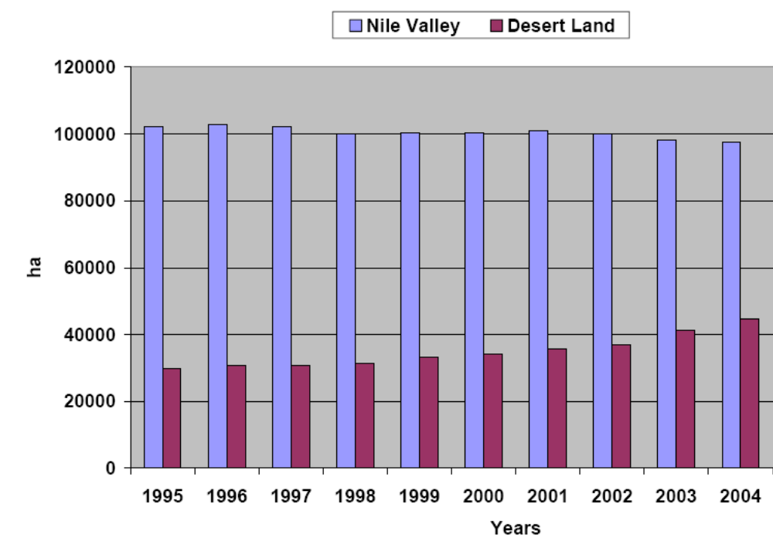
Source: Hofer (2006)

Export volumes have more than doubled in the same period (Figure 2). More than 600,000 tons were exported in 2005 and it is expected that Egypt will export close to 1 million tons of fresh citrus fruits by the year 2010 (Hofer, 2006).

- Egypt’s citrus production and exports, 1995 – 2004 (Million tons)
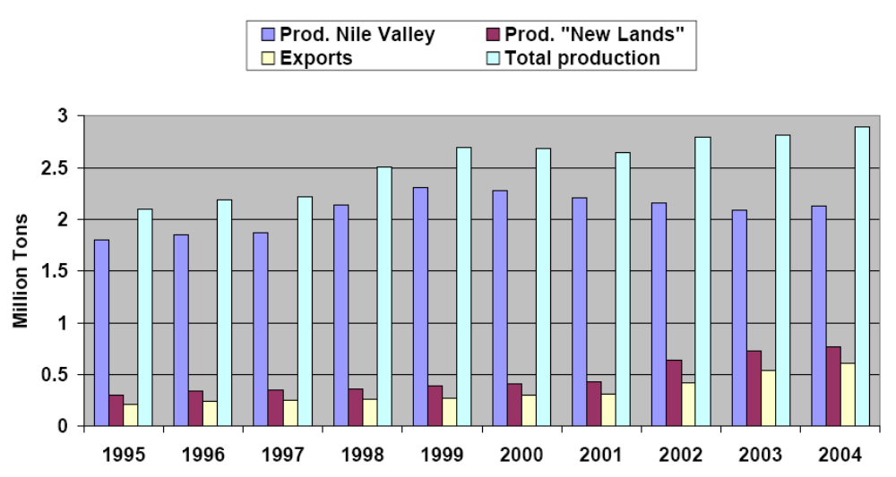
Source: Hofer (2006)
The national average citrus yield is very low compared to world levels. It reached only 18 tons/ha in 2003. The main reasons for the low productivity are inappropriate cultivation practices (i.e., old trees, lack of regular pruning, off-type cultivars, and poor irrigation practices) and graft-transmissible diseases. These diseases are known to affect and to endanger the citrus industry worldwide and had proven devastating effects on citrus longevity, quality and quantity of the crop all around the Mediterranean.

The main mode of spread of these diseases is through infected propagating material. Infection rates are increased as well by top-grafting of newly introduced citrus varieties of great economic importance. The absence of effective sanitation, certification and quarantine programs in Egypt until 2003 has contributed significantly to deteriorate the citrus sanitary status. Until 2001 the origin, the variety and the sanitary status of the propagating materials were largely unknown as the public and private nurseries were then multiplying the material mostly under open field conditions.

Compared to its competitors in the Mediterranean Basin, Egypt fetches the lowest prices for its citrus exports. Morocco for example received an average f.o.b. price of 700 US $ per ton for Clementine oranges and 550 US $ per ton for navels in recent years. Egyptian exporters were paid less than 400 US $ per ton in the same period. This means a loss of more than 40 million US $ in 2005 for navel orange exports alone.

These price differences are evidence for the second major obstacle of the Egyptian citrus sector. Low export prices suggest how the market assesses the quality of the traded product. Egypt for example has not been successful yet to make full use of its export potential to the EU. Less than 10% of the exported volume went to this premium priced quality conscious market in recent years.

The third obstacle for the sub-sector to realize its full export potential is the absence of processing facilities (e.g. for juice). These would allow the local industry to increase its receiving capacity during the harvest season, avoid the extremely low prices during this period on the local market (retail prices of 0.2 US $ per kg), reduce storage costs and prevent an oversupply of the local market in the coming years of increased production.

In 1999, GTZ assisted the Egyptian Ministry of Agriculture and Land Reclamation (MALR) to develop and implement the Citrus Improvement Program (CIP) (1999 – 2006) with the objective to substantially improve the competitiveness, quality and export potential of citrus fruits under a sector strategy worked out with all relevant stakeholders.

In addition to the agronomic part, the mass production of improved, pathogen-free citrus planting material in Egypt was a necessary step to achieve the goals of better quality and increased export volumes for higher priced markets such as Western Europe. To this end, GTZ assisted the relevant institutions in the public and private sector to develop a citrus certification scheme that would test and license planting material in line with international standards. The use of such improved planting material in private nurseries and orchards would substantially improve the productivity and competitiveness of citrus production in Egypt.

Project Approach to Intervention:
The following interventions were carried out in cooperation with MALR:

- Between 1999 – 2002, eleven out of 56 local citrus varieties were selected for their agronomical performances and sanitary status, and submitted to sanitation in collaboration with the Mediterranean Agronomic Institute in Bari, Italy.
- Screened and sanitized pre-basic material for eleven varieties was imported from Italy and multiplied as the mother root stock for all future multiplication in nurseries in Egypt
- 28 certified varieties and rootstocks were imported from California and multiplied in the country.
- The citrus certification schemes of California, Italy, Spain and Morocco were analyzed and reviewed.
- The first state-of-the-art public and private citrus nurseries were established.
- An indexing program was developed to test all local and imported varieties for the presence of graft-transmissible diseases.
- A laboratory was set up for regular testing for the presence of relevant pathogens.

The following interventions were carried out in cooperation with MALR and the private sector such as nurseries, growers and exporters:

- Development of a common strategy for the sub-sector with participation of all relevant stakeholders
- Elaboration of the legal framework for citrus certification.
- Drafting of a law for the licensing procedures for citrus nurseries.
- Training and knowledge transfer to public and private nurseries on international standards for certification and the required technologies and investments to produce pathogen-free citrus planting material.

Project Impact
CIP monitoring data (Table 3) shows that by the year 2006 the private nurseries cooperating with the program will be supplying 40% of the local demand with improved planting material (1.6 million trees). In 2010, two thirds of the local market will have access to this material (2.6 million trees).

The price per tree rose from 0.30 US $ to 1.10 US $ per piece. The demand is far beyond capacity.

The yield increase through improved planting material was monitored. CIP data indicates an increase of at least 12 tons per ha of exportable fruits. In the "New Lands", where most of the new orchards are established, the quality for potential exports has improved significantly since.

When the first batches of improved planting material will be bearing fruits by the year 2010, the annual benefit for the sector is expected to be more than 14 Million US $ per year. This compares very favorably with total project cost of less than 7 Million US $ in seven years of implementation (1999 – 2006). This will represent an area of approx. 6% of the total Egyptian orchards planted with citrus by 2020.
- Citrus Improvement Program (CIP) impact
 | Scenario 1*  (projected by CIP) | Scenario 2**  (CIP data for 2006) | Scenario 3***  (pessimistic)
Improved planted material  (million plants sold per year after 2010) | 2.6 million | 1.6 million | 0.8 million
Replanted or newly planted area  (ha per year after 2010 – mostly ‘new land’ in the desert) | 4,700 | 2,999 | 1,450
Yearly benefits after 2010 (US $)  (CIP Monitoring Data) | 23 million | 14 million | 1,450 million
% of Egypt’s citrus area planted with improved trees by 2010 | 10% | 6% | 3%
Internal Rate of Return (IRR)  (at constant 2005 prices) | 38% | 32% | 24%
The demand for improved and more costly planting material keeps up with supply. 2.6 million trees will be planted in Egypt per year. 10% of Egypt's Citrus area will be planted to improved varieties by the year 2010
** The size of replanted or newly planted orchards per year remains as monitored by CIP in 2005/2006. Demand for improved trees remains at the level of 2006.
*** The areas of replanted or newly planted orchards are reduced by half
Source: Hofer (2006)

Lessons Learnt
Favourable economic framework conditions, such as heavy investments of the private sector in new plantations in the desert and the devaluation of the Egyptian currency, have helped on the demand side for improved planting material and led to increasing export volumes of fresh fruits.

International expertise in citrus certification and the application of new technologies by the leading producers and nurseries were essential to convince farmers of the potential of quality planting material, even at considerably higher prices. Establishing a certification scheme within strict regulations for the citrus nursery sector has substantially improved citrus productivity in Egypt.

Even under very pessimistic assumptions, the Internal Rate of Return of the project is at 24% and may reach more than 30% at constant costs and returns, based on the project's present monitoring data of the 2005/2006 season (Hofer, 2006).

Conclusions
Horticulture in Egypt is an activity of great importance both to economic and agricultural sector growth because it utilizes a significant and increasing portion of arable land, provides employment to millions of Egyptians, offers considerable room for expansion in both export and domestic markets, and can generate substantial foreign exchange and income.

The advantages of horticulture over field crops is that horticulture includes a generally higher return relative to land, to water, and to labour, and provides greater opportunities for differentiation and value-added than field crops.

Despite the significant growth in exports that has already occurred, a small number of Egyptian horticultural products still command a minor market share in a relatively few export markets. This indicates significant potential for further increases in sales to current markets as well as for entry into new markets.

The two intervention policies reviewed in this chapter have been instrumental to the process of expanding the production and export of a limited number of horticultural products (i.e., high value crops and citrus fruits). Future intervention activities in the horticultural sector, however, should cover the entire sector, not just export horticulture, because (i) exports are likely to remain a fairly small percentage of overall volume marketed, (ii) upgrading domestic production and marketing solidifies the foundation for exporting, and (iii) fresh produce feeds into and complements processed produce.

The principal constraints to continued development of Egypt’s emerging export sector in non-traditional crops relate to delivered product cost and quality. With total supply from Egypt and other countries increasing and Egypt increasing its market shares, delivered costs, insurance and freight (CIF) are becoming a significant issue. Increased supply and importer quality requirements also increase the need to produce and deliver product that meets buyer specifications.

Present efforts for export markets have focused mainly on large-sized farmers, but future efforts should offer export markets to small and medium-sized holder farmers. Small and medium-sized holders, especially those who own their own land, spend a much greater portion of their increased income from horticultural export products in their villages than do corporate farms and absentee landlords, who purchase inputs in major cities or directly from foreign suppliers and do not leave the profit from their operations in rural villages. The risk to exporters in using small and medium-sized holders is that emerging quality assurance requirements, such as Global GAP, will prove too costly or risky to justify working with smallholders, as is happening to some extent in the Kenyan fine green bean sector.

TUNISIA OLIVE OIL SECTOR

Introduction
The liberalization of foreign trade and the opening of agro-food industries to private companies are diversifying the Tunisian agri-food sector whilst making it more export-oriented. This is after having focused on activities, with the possible exception of olive oil, that have aimed at import substitution.

The most striking example of modernization remains olive oil, of which Tunisia is the world’s second largest producer after the EU. The sector has witnessed an incredible revolution since 1994. This has corresponded with the abolition of the monopoly on olive oil exports formerly retained by the state-controlled Office Nationale de l’Huile (ONH). The private sector responded to the opening up of the market and the ratio of olive oil export earnings to olive production hit new levels after 1994 (Figure 3). The value of olive oil exports in 2004 was US$ 569 million, or 6% of the country’s total exports.

- Ratio of Tunisian olive oil export earnings to olive production, 1961-2004 (US$)
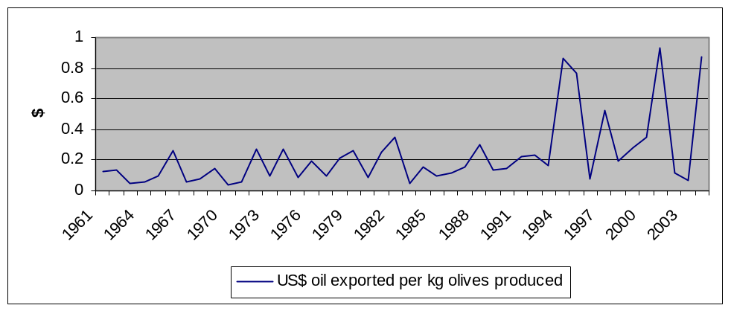
Source: FAOSTAT

Initially, private firms were allowed to export to markets outside the EU while ONH kept the privilege of exporting to the EU. Since the 2001-2002 season, private firms have been authorized to export olive oil both in bulk and bottled forms (aside from organically produced oil) to EU countries. However, they can do so only if they pay tariffs, rather than through the ONH’s annual 56,000 tons quota that was granted to the Tunisian government under a preferential agreement with the EU. As a result, within a few years, the number of bottlers and exporters of olive oil has surged from zero to about 93 (Karray, 2005). These new operators contributed on average to 43% of total olive oil exports between 1995 and 2002 (Table 4).

- Contribution of the private sector to Tunisian total olive oil exports, 1995-2002 (‘000 tons)
 | 1995 | 1996 | 1997 | 1998 | 1999 | 2000 | 2001 | 2002
Total | 90.2 | 29 | 126 | 124.1 | 163.9 | 113.9 | 90.3 | 22.2
ONH | 78.3 | 24.4 | 65.3 | 91.6 | 67.1 | 42 | 40.5 | 13.3
Private | 11.9 | 4.6 | 60.7 | 32.5 | 98.8 | 71.9 | 49.8 | 8.9
Private (%) | 13.19 | 15.86 | 48.17 | 26.19 | 59.06 | 63.13 | 55.15 | 40.09
Source: (Olive Tree Institute, 2005)

As the main regulator of the market ONH buys olive oil from local producers when supply outstrips demand. As a result, it plays an important function which private companies are, at this point, still unable to match. The private sector does not have the money or infrastructure to maintain the stability of the market.

Although still restricted, the opening up of the market has led to a considerable improvement in the marketing of the country’s olive oil. This has enabled private firms to explore new markets, thereby diversifying Tunisia’s client base by exporting to emerging markets (i.e, USA, Canada, Japan, Russia, Australia, Brazil, Argentina, Saudi Arabia, etc.) (Table 7). Although the quantities exported to these markets remain limited compared to exports to the EU market (outside quota) (about 87% of Tunisian olive oil exports are directed to the EU, namely Spain and Italy) (Figure 4), this orientation requires support. A government olive oil campaign to boost exports that facilitated the export of over 110,000 tonnes ended in October 2006. It is uncertain if the market can sustain this level because some Tunisian exporters took losses when European demand sank in response to increased prices, which led to foreign importers halting purchases of Tunisian olive oil. Rather than market olive oil at cheaper prices, Tunisia accumulated and stored production. The stocking capacity of the ONH is set at 140,000 tonnes. When demand picked up again, another 25,000 tonnes were marketed at prices lower than before, with 110,000 tonnes sold, reaping TD600m ($461.53m). About 50,000 tonnes of stocked oil were not sold. Tunisian exporters, who had purchased the produce at high prices, bore losses because of the lowered market prices caused by market fluctuations. Experts have recommended that, in the future, reference prices should be installed for coming seasons so that exporters will be protected from possible future losses (Oxford Business Group, 2007b).

- Evolution of Tunisian olive oil exports to the European market, 1991-2005
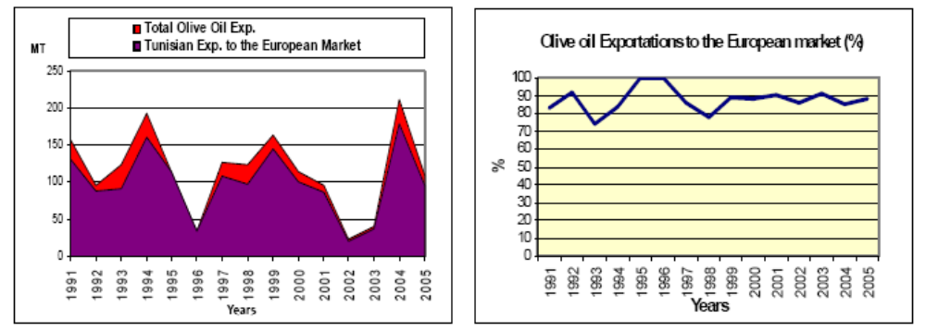
Source: (Karray, 2005)

This new orientation has also forced the country’s 1800 oil mills to modernize, thereby meeting European and international standards with the production of high quality extra virgin oil, which is produced in an organic and natural environment. It also has considerably increased olive oil exports in bottles and cans rather than those in bulk, as was the case before 1995, and help setting and launching Tunisian marks. The production of high quality olive oil and packaged olive oils has been supported by the government within the framework of a National Program of Total Quality supervised by the Industries Promotion Agency and the National Program to Promote Packaged Olive Oil Exportations (see section 3.3.1). However, still about 99% of Tunisia olive oil exports are marketed in bulk (Karray, 2006).

In parallel, domestic prices for olive oil production, which are set by the government each year, were relaxed to adapt (to some extent) to the rules of the market. With a view to safeguarding producers’ interests in foreign markets, ONH adopted a new policy in 2001/2002. This consisted of the continual application of intervention prices paid in advance, but followed by an additional amount if a profit is made (as determined at the end of the marketing season). Within that process, a trading price is determined at the start of each month on the basis of international market conditions.

The emergence of private-sector exporters within the framework of market liberalisation implies that their taxed sales in the EU will remain constrained by competition with EU producers, such as Italy and Spain. Firstly, olive oil exported to the EU faces tariffs of €1.20 or €1.30 per kilo. Secondly, while olive oil production is not subsidized in Tunisia, it is in the EU (see section below). EU growers, representing around 70% of the world’s olive oil supplies, are paid $2.3bn each year from the EU budget. This represents over one-third of the world’s $5.7bn in olive oil production value. Even with improved marketing and reduced costs, Tunisia will have a hard time overcoming that barrier.

The objective of this chapter is to provide an overview of initiatives aimed at revitalizing Tunisian olive oil exports. The document focuses on two government interventions: the National Program to Promote Packaged Olive Oil Exports aims to increase the percentage of olive oil that is conditioned in Tunisia (with a Tunisian brand) in order to add value to the final product rather than the traditional export policy of selling in bulk. The second policy intervention aims at promoting organic olive production hence Tunisia’s olive oil sector can take advantage of increasing international demand for organic agri-food products. Both cases illustrate how the public sector can support the private sector to become more competitive and take advantages of increasing international marketing opportunities.

Factors Influencing Policy Interventions in Tunisian Olive Oil Sector

Internal Factors
- Olive Oil Production Systems
The concentration of about 70% of oil olive trees in the Middle and South of Tunisia where climatic and edaphic conditions are general restraining (drought and marginal lands) limits considerably improvements in plantation productivity. These regions account for 81% Tunisia oil olive production. Plantation of olive oil trees in the North, where the climatic conditions are distinctly more favourable, is marginal (Table 5).

- Average Tunisian Olive Oil Production, 1990-2002
Region | Area  (‘000 ha) | Production  (‘000 tons) | Yields  (Kg/ha)
North | 177.5 | 140 | 789
Centre | 1,185 | 525 | 480
South | 249 | 76 | 307
Total | 1,611.2 | 741 | 460
Source: (Olive Tree Institute, 2005)

In spite of its adaptability to most difficult edaphic and climatic conditions, the olive tree is a genetically alternating crop. This phenomenon is further aggravated in the arid and semi-arid regions due to the lack and unevenness of rains (torrential rains or successful dry years), and the bad quality of soils reserved to this crop, in marginal zones lacking potentials or containing some damaged and un-conserved lands. The fluctuations of the olive product affect the productivity, the production cost, the income and accounts balance, and result in an inability to reiterate this activity (Figure 5).

- Evolution of Olives Production in Tunisia, 1991-2005
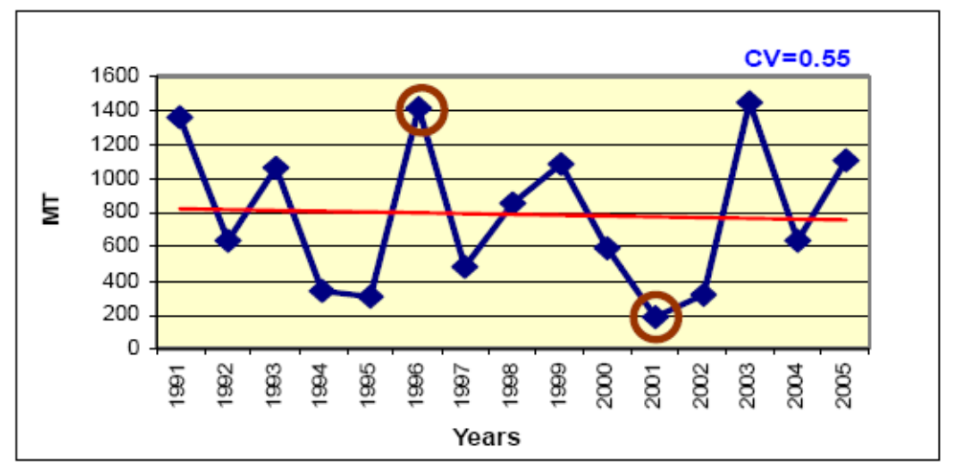
Source: (Karray, 2005)

Irrigation of olive oil trees is not a tradition in Tunisia, hence there is only a very small irrigated oil olive tree area (40 thousand ha out of 1685 thousand ha). However, increases in oil olive sale prices in recent years has reinforced the profitability of this crop encouraging investments in irrigation systems notably in the North and the Middle of Tunisia where plantation densities are much higher (270 to 1250 trees per hectare) (Karray, 2005).

- Olive Oil Export Systems
Despite its traditional export focus and government financial support through the Foreign Markets Access Fund (FMAF 1 and 2), there is a lack of market intelligence and the sector is failing to respond to changing consumer demands in international markets.

- Product Quality
Tunisian oil exports mainly consist of the lowest grade of virgin oil, the lampante olive oil, which amounts to about 60% of its oil exports. Only 25% to 30% of its oil is high-quality compared to rates of 70% to 86% observed in European competitor countries. This low rate is the result of various factors such as: (i) inappropriate harvest, storage and transport methods; (ii) a long harvest and storage cycle; and (iii) obsolete extraction equipment, which accounts for 42% of capacity (The World Bank, 2006). Olive mills with modem equipment currently represent 31% compared to 70% - 80% in Italy, Greece and Spain.

The lack of horizontal and vertical integration among actors in the chain does not facilitate involvement in total quality program and limits the possibilities to reduce olive oil production cost.

- Tunisia share in the European market of olive oil according to the qualities, 1990-2001 (%)
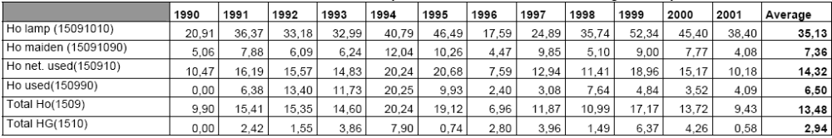
Source: (Olive Tree Institute, 2005)

External Factors
- Growth in European Demand for Olive Oil
EU olive oil imports (intra and extra communal) reached 847.6 thousand tons on average, during the period 2001-05, compared to only 472 thousand tons between 1991 and 1995. However, Tunisia has not benefited from this slight increase in EU olive oil imports (Karray, 2006). The imports coming from Tunisia have gone down to reach 83.3 thousand tons during the period 2001-05, while they were 117 thousand tons between 1991 and 1995. This decrease has resulted in the regression of the Tunisian position on the European market. The European olive oil imports coming from Tunisia have represented 10% of the total imports and 60% of the imports coming from the third countries during the period 2001- 05. This contribution was respectively about 25% and 91% during the period 1991-95. The Tunisian market share is only 8.8%. Between 1991 and 1995, this market share was 17.2%.

- Growth in Demand for Olive Oil in Emerging Markets
Imports by emergent market, such as the USA, Canada, Japan and Australia, that represent the main Italian and Spanish oil destinations, has increased considerably since the beginning of the 90s (Table 7). Tunisia has slightly benefited from this increase in the USA market Its market share has reached 2.6% on average between 2001 and 2005, while it was 1.8% during the period 1991-95. This market is dominated by the Italian and the Spanish exporters who occupy 68.5% and 17.4% respectively.

- Evolution of olive oil import in USA, Canada, Japan and Australia (ton)
 | USA | Australia | Canada | Japan
1991-95 | 111,326 | 15,519.8 | 12,117.2 | 5,980.8
1996-00 | 173,624.6 | 22,606.8 | 20,322.8 | 29,379.2
2001-05 | 216,165.75 | 29,202.25 | 25,011 | 30,984
Source: FAOSTAT May 2006 +IOOC

- Import duties applied by the EU for olive oil imports from outside countries
This MFN tariffs applied to the European olive oil imports coming from third countries in normal regime are fixed by items 13 and 14 of the basis regulation n° 136/66/CEE. This regime witnessed a deep modification within the framework of the Agricultural Agreements of Uruguay Round. The variable tariffs have been replaced by the equivalent tariffs subjected to discount of 20%. These equivalent tariffs correspond to the difference between the price of entrance at the border and the medium world prices for the period 1986-88. This difference has been assessed to 1,556 Euros/tons for the virgin non-lampante olive oil, to 1,532 Euros/tons for virgin lampante olive oil, and to 1,682 Euros/tons for the refined olive oil during the year 1995 (Table 8). The tariffs, coming into force at present, amount to 1,245, 1,226 and 1,346 Euros/ton respectively. However, the clause specifying expected safeguard, regarding this matter, authorizes taxation of an additional deduction in case to the alert price.

- Equivalent Tariff and Alert Price for Olive Oil (Euros/ton)
Olive Oil | Equivalent Tariff 1995 | Equivalent Tariff 2000 | Alert Price
Virgin lampante | 1,532 | 1,226 | 1,361
Virgin un-lampante | 1,556 | 1,245 | 1,682
Refined | 1,682 | 1,346 | 1,101
Source: European commission

The modification brought to the CMO, in 2004, stipulates, in Article 11 of Regulation 865/2004, that if the market price of olive oil in the EU exceeds of 1.6 times the prices listed in the item 6 (Table 9), during a period of at least three months, it may be decided, in order to assure an appropriate supply in olive oil for the common market through imports from non-member countries, in accordance with the procedure aimed at by the item 18 of the same regulation:

- To suspend totally or partially the application of MFN tariffs to olive oil, and to establish the detailed arrangements for any such suspension.

- To open up a quota of olive oil importation, to which apply common reduced MFN tariffs, and to define modes of management of this quota.

- Intervention price for the storage and the olive oil importation
Olive oil | Storage price  (Euros/ton) (Article 6) | Common market price  (Euros/ton)
Extra virgin | 1779 | 2846.4
Virgin | 1710 | 2736
Lampante | 1524 | 2438.4
Source: EC Regulation No. 865/2004
http://eur-lex.europa.eu/LexUriServ/LexUriServ.do?uri=OJ:L:2004:161:0097:0127:EN:PDF

The application of these measures, however, could disadvantage Tunisia. EU operators have the possibility to act on olive oil prices and avoid the excess to the level fixed by item 11, within a period of at least 3 months. If these measures are put into action, they could encourage exports of third countries to the EU market, offering new opportunities for Tunisia olive oil exports, but negatively affecting the preferential advantages granted to Tunisia while reinforcing the competition from other third supplier’s countries. Hence, Tunisia should reinforce its price and structural competitiveness with regard to potential competitors in order to save its interests (Karray, 2006).

- The emergence of new producing and exporting countries of olive oil, benefiting certain preferential tariffs on the EU market within the framework of association agreements (quota with no MFN tariffs)

- EU Subsidies Paid to European Olive Oil Producers.
In 2003, the European commission decided to insert production aids in the single payment to the farm topping 60% (100% for farmers having a surface area inferior to 0,3 hectares) of the amount received during a definite reference period with regard to seasons 2000/2001, 2001/2002 and 2002/2003. In order to avoid the abandonment of olive trees, 40% of payments to olive oil during the reference period will be assigned to EU Member States (MS) in the form of a national envelope (Table 10). This budgetary envelope will be devoted to the granting of aids to the olive grove, by hectare or by tree, not related to the production, and intended to maintain olive trees, and to preserve soils and environment, while taking into consideration the local traditions. It will be the MS’s concern to designate zones on the basis of a framework to be set up by the European Commission, while respecting a maximum of five categories of olive groves to be granted aids according to their environmental and social value.

Zones of olive groves planted after the 1st of May, 1998, except those inclusive in the new plantation plans approved by the European commission, will be excluded from the single payment regime by farm and by olive grove. The single payment and the aids for the maintenance of olive groves having environmental and social value are applicable from January first, 2006.

- Distribution of the budgetary envelope according to member countries
Countries | Budgetary envelope  (Million Euros)
Spain | 412.45
Italy | 272.05
Greece | 208.14
Portugal | 22.66
Cyprus | 2.93
France | 2.1
Slovenia | 0.17
Malta | 0.07
Source: European Commission

Policy Interventions to Revitalise Tunisian Olive Oil Exports

National Programme to Promote Packaged Olive Oil Exports
99% of Tunisian olive oil exports to the EU involved entreated oil in bulk, which deprives Tunisian exporters of the value added associated with refining, packaging, marketing and product identity. In 2005, the Tunisian government authorized private exporters to export organic olive oil and olive oil in bottle under Tunisian mark in the framework of the quota granted to Tunisia by the EU. It also set up a promotion fund for olive oil in package aiming at moving gradually away of the current system of selling olive oil directly to wholesales/exporters in bulk at low prices, and instead increase the percentage of olive oil that is conditioned in Tunisia (with a Tunisian brand) and then sold to wholesales from the current 2% to 10-20% within three years. This fund is meant to provide financial support to individual enterprises or group of enterprises, consortium or professional association involved in the production of olive oil in package, or its exportation, except for international trade societies. The project, financed by a 5% export tax (levy), funds marketing activities by integrating the Tunisian brand higher value added niche markets, through international distribution chains.

This fund supports specific actions seeking to reinforce the capacities of an enterprise or a group of enterprises in order to promote their exportations, especially by increasing their value (i.e., participation to fairs and shows and markets prospecting; the setting up in foreign countries of structures of commercialization, distribution and marketing; search for intermediaries in the target markets; adaptation of products packaging to the markets demands; purchasing and recording trade marks; setting quality labels; elaborating communication supports to bring to light the enterprise, its activities and its production; referencing of oil in big shops in foreign countries; analysis of packed olive oil in exportation).

The aid of this fund is granted in the form of allocations that amount to 70% of the cost of actions of common interest, and to 50% of the cost of specific actions, with a ceiling of 70 thousand Dinars per year and per enterprise. These allocations cannot be drawn simultaneously with those granted by the other funds. The management of this fund is responsibility of the “Tunisian Council of Olive Oil in Package”.

Promotion of Organic Olive Production
International demand, especially from the EU, has helped organic farming become one of the country’s fastest-growing export businesses. Tunisia ranks 35th globally in organic production, was one of the first African countries to grow organic foods and is the only African country with its own EU-compliant organic standards, certification and inspection system. The certification system, along with Tunisia’s climate and its proximity to Europe, gives it a competitive edge in the EU market for organic olive oil.

Small organic farms in Tunisia started producing crops in the 1980s, but it was not until 1997 that business started to boom. The Tunisian government is committed to promoting organic produce and created a national regulatory framework with Law 30, which was enacted April 5, 1999 and finalised in 2001. This law contains incentives and measures for promoting the sector. The reference legislation uses many guidelines laid out by the International Federation of Agricultural Movements. A National Commission for Organic Agriculture helps supervise incentive programmes in the organic farming sector, which include subsidies for equipment, certification, research, training, farm associations and marketing.

Developments include scientific research on topics such as organic fertilisers, pest and disease control, and professional training including short courses for technicians and farmers to master’s programmes at universities. Numerous organisations and structures
have also started up, including the Bureau of Organic Agriculture and the National Federation of Organic Farmers. Since Law 30 was enacted, the numbers of producers and organic agricultural zones have increased four-fold and five-fold, respectively (Table 11).

- Evolution of Tunisia’s organic agricultural area, 1997-2001 (ha)
 | 1997 | 1999 | September 2001
Area (Ha) | 300.0 | 15035.7 | 16818.0
Source: (Ben Khedher & Nabli, 2002)

Olives and dates dominate the organic market, with the former constituting 67% of produce for this market (Table 12). The olives and olive oil sector has 62 producers, the majority of which are located in the Sfax and Sbeitla regions.

- Production and exports of Tunisia’s main organic crops (Tm)
Organic products | Production |  | Exports
Organic products | Season  1999/2000 | Season  2000/2001 | Season  1999/2000 | Season  2000/2001
Olive oil | 3000 T Oil  (15000 T Olives) | 1000 T Oil  (5000 T Olives) | 400 T | 600 T
Date palms | 400 T | 2500 T | 400 T | 670 T
Vegetables  (potato, artichoke, tomato, cucumber, aubergine) | 200 T | 400 T | 200 T | -
Almonds | 20 T | 25 T | 20 T | -
Aromatic and medicinal plants | 20 T  (3 T of Dry Matter) | 30 T  (5 T of Dry Matter) | 20 T  (3 T of Dry Matter) | -
Jojoba | 6,5 T | - | 6,5 T | -
Vine (wine) | 400 hl | 400 hl | 400 hl | -
Source: (Ben Khedher & Nabli, 2002)

For organic olive oil production, growth is limited by conditioning process. At present, there are only eight olive transformers. The majority of Tunisian organic production is exported to the EU, namely France, Belgium and Germany.

Seeds, seedlings and other agricultural supplies used in organic agriculture are bought from both local and foreign sources, with some certifiably organic and others merely untreated by chemicals.

A challenge for organic farmers is that many farms have poor soil fertility characterised by low organic matter content and low biological activity, as well as poor structure. Soil improvement is difficult and would entail introducing green manure into rotation, training farmers for compost management and finding certified organic and mineral fertilisers in sufficient quantities in Tunisia. Import of organic matter remains prohibited. The control of some pests and diseases remains inefficient, because many products that are certified organic cannot be found in the country. To remedy this, a list of authorised organic products is in the works. Nevertheless, there is no real market for organic products within the country due to a lack of awareness and budgetary concerns. The bulk of production is geared for export.

The inspection and certification bodies handling organic farming include Tunisia’s National Institute for Standardisation and Industrial Property, Bioagricoop from Italy, France’s Ecocert, Germany’s Lacon and the Association of Italian Biological Agriculture.
Tunisia has a very limited scope of organic products when compared with its competitors. The certification costs for Tunisian farms are high, ranging from €1500 to €2300 per year, mainly due to the lack of approved certifying organisations in the country.

With further development and evolution of the organic farming sector, it would be possible to increase production 10-fold and attain over 1% of the arable lands used in 2007. The Ministry of Agriculture is already considering the possibility of converting 5000 ha of land to organic farms from 2008 to 2012. The main difficulties in converting farms from standard into organic formats are the lack of fertilization and soil-treatment products, suitable pest and disease control products, a lack of organic agriculture equipment such as compost and weed management tools, a lack of unrestricted veterinary medicines and the absence of organic product marketing expertise.

Conclusions
Despite quality problems, the Tunisian olive oil sector is proof that supply chains can respond to Government policies. In 1994, when Government removed the ONH’s monopoly on olive oil exports, the private sector responded and the ratio of olive oil export earnings to olive production hit new levels.

The sector shows a high dependency on the EU market; however it has not been able to benefit from recent growth in EU olive oil imports because exports are mostly marketed in bulk and mainly consists of the lowest grade of virgin oil (lampante olive oil). ONH has traditionally focused on satisfying the annual contingent granted to Tunisia by the EU without intensifying development efforts in new and emerging markets. This conservative strategy has hindered the development of differentiation strategies and penetration in alternative, emerging markets.

The liberalization of the market has made the sector more responsive to international market demands; though still face competition from ONH in export markets. Since the involvement of private operators in the collection and commercialization of olive oil, these operators have slightly varied the destinations of this product that has taken place on the emerging markets. Although the quantities exported to these markets remain limited compared to exports to European market (outside quota), this export market orientation requires support.

Certain oleifactors or exporter-oleifactors have undertaken actions to improve the quality and packaging of olives produced, together with setting and launching Tunisian marks. This new orientation has been supported by the government. The quantities of packaged olive oil exported at present are only 1% of the total olive oil exportations. Packages used are glass bottles and metallic cans, generally imported which increases significantly production costs.

FRESH CUT HERBS IN JORDAN

Introduction
The agricultural sector employs 4% of the country’s economically active population, contributes 2.8% to GDP (2005) and generates 11.4% of Jordan’s exports principally in the form of food commodities and live animals, dairy products, eggs, fruits, nuts and vegetables (IFAD, 2007). Although the sector is small in relation to the overall economy, it is important not only for the production of tradable goods but also for its strong up and downstream linkages, as a result of which an estimated 28% of GDP is considered as agriculture-dependent.

The agricultural sector started to witness declining growth rates during the late 1990s. This decline was attributed to the policy of trade liberalization adopted by the government in 1994, and to the Structural Adjustment Program of the Agricultural Sector (ASAL) in 2000. This trend increased with the implementation of measures related to Jordan’s accession to the WTO, where measures undertaken for the protection of local production from external competition where abolished, except for a small percentage of custom duties on the import of certain commodities. Subsidies have been totally lifted and national agricultural products have had to compete with imported goods in the domestic and export markets. These developments coincided with a decline in the quality and quantity of water available for irrigation, which affected crop productivity and quality of produce and its competitiveness, in quality and price, in domestic and export markets. The fear is that these factors may deepen the declining trend in the agricultural sector output on the medium and long terms, and seriously affect the sustainability of social and economic development, unless measures are taken to address these problems (Jordan’s National Strategy for Agricultural Development, 2002-2010, Chemonics International Inc., 2005a).

About 80% of the country’s staple foods, mainly cereals, are grown in rainfed areas where the majority of farmers are smallholders and much more disadvantaged than those living in irrigated areas. Moreover, the lack of diversification within many production systems exposes farmers unduly to climatic variations, pests and diseases and price fluctuations. This leads, in turn, to fluctuations in income levels during the year; contributes to environmental degradation; and fail to take advantage of complementarities (e.g. between livestock and crop production).

In an attempt to improve incomes and livelihoods of the rural poor, the government in its National Strategy for Agricultural Development (2002-2010) has made an strategic objective the introduction of high value crops suited for small-holdings, such as medicinal and herbal plants, in order to facilitate the re-introduction of small holdings in the agricultural production system (Jordan’s National Strategy for Agricultural Development, 2002-2010, Chemonics International Inc., 2005a).

Medicinal herbs and aromatic plants (MHAP) possess higher water use efficiency, relatively higher economic returns per unit area compared to conventional crops, and the potential to add value through processing and marketing. Moreover, there is increasing demand for fresh herbs both domestically and international. Jordan’s unique climate and diverse agro-ecosystems allows MHAP production on large and small-scales all year round.

However, taking full advantage of trade opportunities requires meeting and consistently maintaining quality standards. Fresh herb in Jordan often lack freshness and are considerably of low quality (Khairallah, 2006). In addition to bottlenecks in production systems leading to low quality, lack of good post-harvest processing and handling, poor packaging and transportation of herbs in vehicles without refrigeration undermines further the quality and quantity of herbs marketed by Jordanian producers. In an attempt to boost production and export of high quality fresh herbs, the Government of Jordan in conjunction with the World Bank introduced in 2003 an integrated program, the Conservation of Medical and Herbal Plants of Jordan project, aimed at improving the quality and quantity of Jordanian fresh herbs (The World Bank, 2003a). The main objective of the programme is to develop models for conservation and sustainable use of herbs for national and global interest and to promote production of herbs with the aim of improving incomes and livelihoods of the rural poor. This chapter provides an overview of the development policy and institutional interventions to promote MHAP production in Jordan and the implementation results of the Conservation of Medical and Herbal Plants of Jordan project to date.

Factor Influencing Policy Interventions in Jordan’s Agricultural Sector

Internal Factors
- Water
Agriculture in Jordan is facing serious problems due to water shortages and land fragmentation. Of Jordan's total area of 8.9 million ha, only 4.3%, mainly in the highlands and Jordan Valley, is cultivable. Jordan is one of the world’s driest countries with the lowest per capita availability of renewable water resources (150 m³ in 2002). Scarcity of water is becoming a major constraint on growth and represents a threat to the agricultural sector, which suffers from over-extraction of groundwater in the highlands and flow of polluted wastewater to the Jordan Valley. Irrigated agriculture is the major water consumer and accounted for 66% of the water consumed in 2000 (Khairallah, 2006). It is expected that demand for fresh water from different sectors will grow fast due to high population growth and greater industrial and tourist demands. As a result, irrigated agriculture will face serious problems in the future, hence the need for new technologies, taking advantage of crops and cropping patterns that will maximize the benefit from each unit of water. It is estimated that about 150,000 ha, mainly of steep slopes, could be developed for agriculture through land reclamation, terracing and fruit tree planting (Chemonics International Inc., 2005a).

National efforts in water harvesting that can provide additional resources for irrigation are still modest (Chemonics International Inc., 2006). The promising Shafa-Ghor areas with suitable rainfall, ideal for the production of early fruits with minimum supplementary irrigation, have also not yet been fully exploited. The great potential to develop natural rangeland has also been ignored in spite of the impact of such development on protecting natural resources and the environment, decreasing imports of animal feed, and integrating plant and livestock production.

It is predicted that climate variability will aggravate the situation by further decreasing water availability thus bringing about additional threats to health, food security, productivity and human security. The ability of Jordan to adapt to increased water scarcity induced by climate change will be crucial to sustaining its human development achievements and growth (IFAD, 2007).

- Land Fragmentation
There is extensive land fragmentation in the highlands, the Jordan Valley and the southern Ghors, and farm holdings are small which constitute a serious constraint on the efficient use of land resources (small production units are unsuitable for mechanized agriculture, resulting in an increasing percentage of large areas left without cultivation) (IFAD, 2007). The legislation passed by the government, allowing partitioning of land ownership outside municipal boundaries into smaller areas, have also contributed to the fragmentation of these ownerships and forcing them out of production (Jordan’s National Strategy for Agricultural Development, 2002-2010, Chemonics International Inc., 2005a).

- Marketing Systems
Jordan has a unique climate that allows the production of wide varieties of horticultural products all year round. Past development efforts concentrated on increasing the production capacity in fruits and vegetables and looked at marketing as a complementary service to production, in a decade of high demand and short supply. As supply grew, the gap between demand and supply grew, causing congestion throughout the marketing channels (Jordan’s National Strategy for Agricultural Development, 2002-2010, Chemonics International Inc., 2005a).

Small-scale operators throughout all marketing channels, including producers, are one of the dominant features of the marketing system. Producers cannot achieve the quality standards required in high value export markets due to the lack of resources required to invest in post-harvest technology. However, access of small-scale and medium-scale producers to these markets could be achieved through contract farming with large-scale producers which would lead to improvements in quality and capitalizing on the successes already of large-scale producers in exporting to Europe and the Gulf. A few large-scale producers are already contracting small producers but more of these farmers need to be encouraged to get involved. A World Bank pilot project introduced in 2002, the Horticultural Exports Promotion and Technology Transfer Project (The World Bank, 2002), was designed to assist the government in supporting the private sector by encouraging large-scale farmers to contract with small- and medium-scale farmers to achieve critical mass as required by target markets.

The marketing system suffers from several shortcomings, including the lack of advanced agricultural know-how for the production of high quality products, the lack of access to markets that demand quality products and pay a premium for it, and the lack of an adequate marketing infrastructure required for proper post-harvest handling to distant markets. These shortcomings have led to an increased marketing cost and margins, low quality produce and low quality packages and packaging (Chemonics International Inc., 2005a).

- Competition in Price and Quality
Most indicators show poor competitiveness in the majority of Jordanian agricultural products. With the exception of the Jordan Valley vegetables, which have strong price competitiveness because of early winter season production, other vegetables, fruit, and cut flowers have not been able to enter export markets. The key factors affecting the competitiveness of Jordanian products are: small size of production and marketing enterprises, absence of producers and/or exporters organizations to integrate these enterprises and assist producers and exporters to use technologies needed to improve quality of produce, reduce production costs and integrate production and marketing activities; government failure to provide the needed enabling environment to encourage the private sector to invest in the marketing infrastructure; and government failure to provide effective support services (such as market research, agricultural extension, financing and market information).

External Factors
- Liberalization of Trade in Agricultural Commodities
The economic reform programs, implemented by the beginning of 1994, reduced government subsidies on irrigation water, abolished feed subsidies, and abandoned purchasing grain legumes from farmers at pre-announced promotional prices. These programs have also cancelled non-custom trade barriers on imported agricultural products and reduced customs duties. Local produce since then has faced stiff competition from imported agricultural products.

In 1998, Jordan joined the Great Arab Free Trade Zone (GAFTA) and trade with GAFTA trade partners has been duty free since January 1, 2005. Exports to GAFTA markets amounted to JD 365.2 million (US$ 521.7 million) and accounted for 92.4% of total agri-food exports in 2005 (Table 13).
Jordan and the EU have signed a Free Trade Area (FTA) that entered in force in 2002. In general, the FTA is asymmetric in favour of Jordan but the latter has been unable to fully benefit from preference provided by the Agreement. For instance, Jordan was unable to fulfil most of the duty free tariff quota for exports to the EU market. In 2005 Jordan and the EU agreed to further liberalise bilateral trade from 2006, when most tariff quotas are to be eliminated and ad valorem tariffs will be reduced or eliminated (for export to the EU market). However, certain seasonally adjusted specific duties for export to the EU (mainly fresh fruit and vegetables) remain in place; duty free quotas remain on exports of cut flowers, potatoes, garlic, cucumbers, citrus, strawberries, and olive oil. In addition, duties on imports of certain alcoholic beverages and tobacco products from the EU will not be abolished. Regarding Jordan’s imports, duty on imports of poultry meat, olive oil, refined sugar, meat preparations, and certain tobacco products remain in place.

- Jordan’s main trade partners, 2005
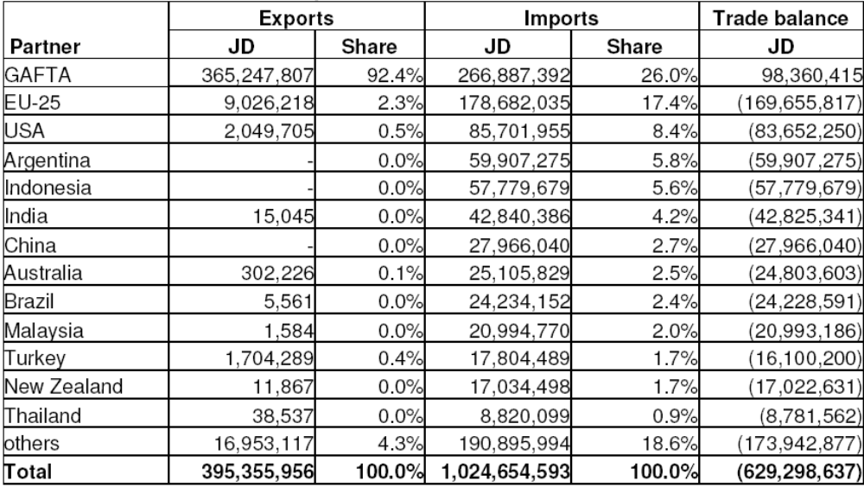
Source: (Chemonics International Inc., 2006)

The Conservation of Medicinal and Herbal Plans of Jordan Project
Fresh herbs can be produced all year around in Jordan due to the multiple eco-systems in the country, in particular due to the warm conditions in the Jordan Valley during the winter. The amount of herbs marketed in Jordan reached 15,000 tons in 2004 (Table 14). Although Jordan produces a wide range of crops, mint, parsley, sage, oregano, fennel, purslane and coriander are the most prevalent. Herbs and vegetables are traded locally but they often lack freshness and thereby they are considered of low quality. The marketing channels are characterized by transport without refrigeration which reduces considerably the product shelf life.

- Fresh herbs traded at main wholesale markets in Jordan, 1997-2004 (tons)
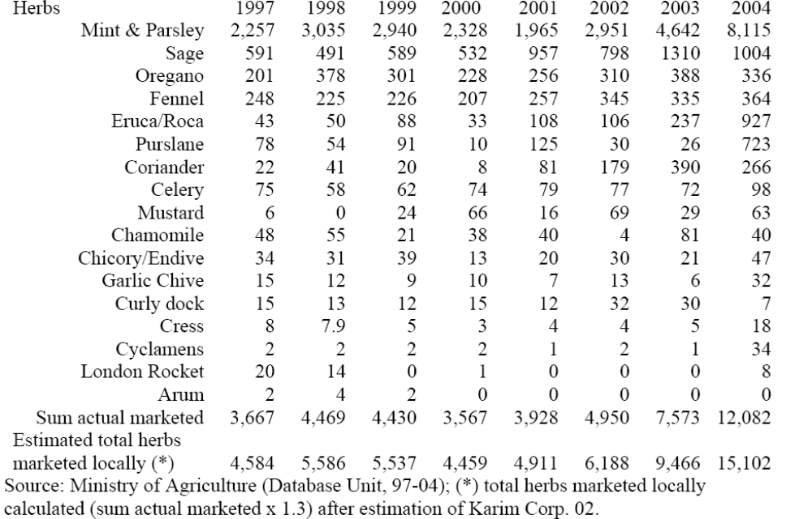
Source: Khairallah (2006)

Fresh herbs are commonly exported to traditional markets in the Gulf States. The variety of exported crops is limited to parsley, oregano, sage and mint (Table 15). The highest demand is for parsley with an amount ranging between 1,000-3,000 tons per year during 1997 – 2004. Fresh herb exports to the Gulf States are transported by refrigerated trucks in bulk without any post-harvest processing or advanced packaging, and sold in bulk at wholesale markets; thus, no attention is given to adding value.

- Herb exports to Arab and non-Arab (EU) countries, 1997 - 2004 (tons)
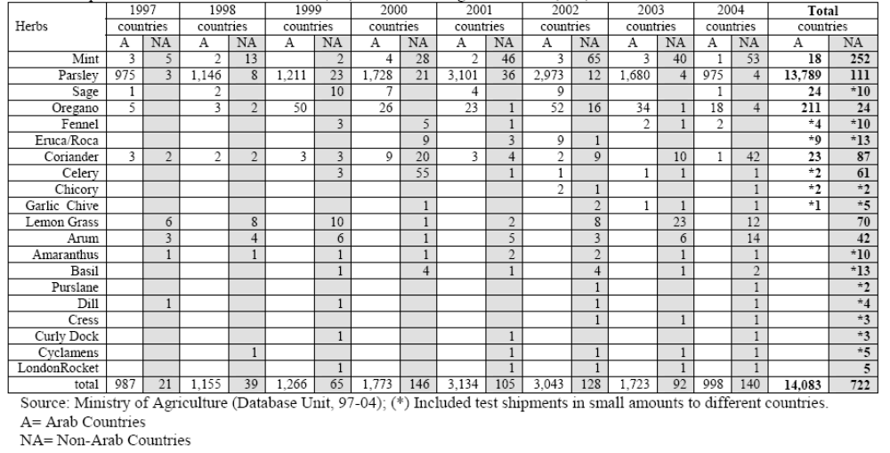
Source: Khairallah (2006)

Since 1996 integrated efforts have been undertaken to promote production and export of high quality fresh herbs in order to tap highly competitive markets (i.e., EU Israel and Turkey). The variety of crops exported to these countries is larger than those exported to Arab states (Table 15). The herbs exported to non-Arab countries amount to 100 tons per year on average in recent years. Producers and exporters are trying to expand their exports hence some of the exported lots to Arab as well as to non-Arab countries consist of test shipments of herbs with better quality and/or new varieties.

Early in March 1997 a national workshop was conducted at the National Center for Agricultural Research and Technology Transfer (NCARTT) to discuss MHAP potential development. The workshop was conducted in the framework of the World Bank "Regional Initiative for Dryland Management" that has devoted special support to MHAP resources development in the country. During the workshop studies and discussion papers were presented on various topics concerning national MHAP resources. Discussions and recommendations highlighted the potential and constraints of the MHAP sector and provided general guidance for subsequent development.

Supported by the ‘Regional Initiative for Dryland Management’, NCARTT conducted various research and development activities. Promising results led to an expansion of the activities in early 2000 through a planning grant from the Global Environment Facility (GEF) under the supervision of the World Bank. In the preparation for an integrated project document three baseline studies were conducted to better understand the MHAP sector in Jordan.

- An inventory study assessed the local MHAP plant biodiversity in terms of conservation and potentials for utilization.
- A study examined the feasibility of growing around 80 domestic and exotic MHAP in the different agro-ecosystems of the country. The study identified constraints related to R&D and the need for concerted efforts among relevant institutions. The study identified (a) feasible crops, (b) target farmer groups and target production areas, (c) fragmented and scattered capacities and facilities available in the country, and (d) the lack of know-how, experience and the need for human capacity building.

- The third study analyzed the socioeconomic characteristics associated with the MHAP sector in Jordan. The study assessed the demand, supply, internal marketing chain and potential export markets for MHAP products. The study concluded that Jordan is importing many MHAP that could be produced locally and when produced in Jordan they should be exported to high quality markets in order to generate maximum added value and income for farmers.

Subsequently, a national 2-day workshop was held in 2002 involving relevant stakeholders such as herbalists, horticulturists, traders and exporters of medicinal herbs and aromatic spices. It also involved scientists and decision makers. The workshop identified the strategy for promotion of the MHAP sector and the role of the different stakeholders. It stressed the need for the private sector to be part of the project.

Based upon findings of the baseline studies, workshops and other preparatory activities the project document was prepared and supported by the GEF with a grant of US$5 m to last for 5 years, while the contribution of the government of Jordan amounted US$9.2 m (in cash and in-kind) (The World Bank, 2003a). The Grant Agreement was signed in May, 2003 between the two implementing agencies; the World Bank and the Ministry of Planning and International Cooperation (MOPIC).

The Conservation of Medicinal and Herbal Plants of Jordan project has two main objectives: (a) to develop models for conservation and sustainable use of local MHAP resources for national and global interest and (b) to promote production of MHAP as feasible tool to improve income of farmers and rural communities. To achieve these objectives the project has four main components; (i) in situ conservation of herbs, (ii) promotion of production including research and development of best agricultural practices, (iii) capacity building for human resources including awareness, higher education and training and (iv) commodity promotion including intellectually property rights standards and specifications, legislations, and marketing.

In terms of linking producers to markets, the project is aiming to promote three main lines of production: (a) production and export of fresh cut herbs, (b) production and export of essential oils, and (c) production of medicinal crops that are in demand by the pharmaceutical industry.

Providing Awareness and Specific Training to Beneficiaries
Awareness-building started early in 1996. Up until now, a number of seminars and workshops have been conducted and information conveyed to interested groups regarding MHAP and their socioeconomic issues concerned with uses, common health properties, potentials for income improvements etc. NCARTT practices a wide range of extension and demonstration activities on farmer's fields to demonstrate the feasibility of growing certain MHAP crops. Mass media campaigns were also launched, focusing on agribusiness trade shows and meetings in the country. This has drawn the attention of producers and consumers as well, and mobilized financiers to think about investing in the sector.

Training is fundamental since specific experience and know-how in terms of production and post-harvest are lacking. The project allocated big portion of its funding for specific training and human capacity building. A number of specialized training workshops for beneficiaries are being conducted and a training schedule in different topics is in place. The project provided research grants for students to be trained in MHAP topics: 12 MSc and 4 PhD students working on graduate research topics identified by the project.

Study tours provide opportunities to learn from the experiences of other countries. A group of interested farmers and technical staff participated in study tours organized by the project to Syria, Egypt, Israel, Holland and Denmark. Other study tours are planned for specific purposes.

Export of fresh herbs, especially to the EU, is a challenging agribusiness, which implies certain measures starting from planting throughout post-harvest, transportation and distribution in order to ensure the product reaches the end consumer in good condition. To capture market share, herbs must be delivered with a consistently high quality and freshness at a competitive price. Major quality standards are Global Gap (EU retail and production good agricultural practice) and HACCP (Hazard Analysis Critical Control Point). Horticultural producers and exporters are aware of these standards – seven producers are already in compliance and more than ten are preparing their facilities to achieve them.

Providing Initial Technical Support and Promotions
The structure for fresh herbs production is similar to that used for producing fresh vegetables. Although the same facilities can be used, fresh herbs are more sensitive and require more precautions, special pre- and post-harvest techniques and machinery. In order to encourage production of fresh herbs and to minimize initial risks the project provides specialized machinery and proper plant materials for use by pioneer producers and exporters. The project has also provided producers with specialized consultancies. A German firm PHARMAPLANT was hired to provide a consultancy for fresh herbs growers. Moreover, an individual consultant (from Israel) is being hired to train and supervise farmers on day-to-day production techniques for export of fresh herbs.

Establishing Linkages Between Actors in the Chain
Building of partnership between small, medium and large producers, exporters and processors of MHAP is crucial for a functioning marketing. The project has established a consortium of agribusiness companies to (i) develop a pilot demonstration farm in key locations to apply advanced production techniques, (ii) establish a production, processing and export business based on contract farming system for the benefit of other small and medium producers. Pioneer producers from the consortium receive special technical support and promotion from the project. Nevertheless, the project is focusing on a broader spectrum of beneficiaries to enhance contract farming and collaborations between different growers and exporters.

Project Impact
Fresh herbs are produced and sold locally with improved quality. Supermarkets have started to devote shelf space to a wider variety and higher quality of fresh cut herbs. Exports to Europe have started and are increasing in volume and variety, which has in turn provided producers with improved income. The greatest challenge is the potential saturation of the market with these new fresh cut herbs and the lack of infrastructure to channel new production volumes to the export market.

Conclusion
The continued fragmentation of agricultural land into small holdings that are no longer suitable for traditional farming or for mechanized agriculture has resulted in low income of small farmers, and in their interest to cultivate these small holdings. Moreover, failure of the agricultural research system in finding proper solutions for problems facing highland farmers, such as drought-resistant varieties, introducing economically valid measures for conserving soil moisture and water harvesting, and introducing and promoting high-value cash crops have further exacerbated the situation. There are also shortcomings in agricultural extension and technology transfer, in training of farmers on new technologies, and in encouraging them to properly use them.

MHAP offers the potential to small scale farmers to diversify their agricultural production systems and improve their incomes and livelihoods by introducing high value crops most suited to their farming structure. MHAP possess higher water use efficiency, relatively higher economic returns per unit area compared to conventional crops, and the potential to add value through processing and marketing. Jordan’s unique climate and diverse agro-ecosystems allows the production of MHAP on large and small-scales all year around. Production and export of fresh herbs is very feasible in Jordan. Meeting and consistently maintaining quality standards is fundamental to the capture of any market share. Jordan has realized the need to promote horticultural exports including fresh herbs and has introduced a number of integrated projects supported by national and international funding.

The Conservation of Medicinal and Herbs Plans projects has led to an improvement in the quality of fresh herbs and exports to European markets are increasing in quantity and variety. The greatest challenge would be the consolidation of incipient investments and the establishment of sustainable business relationships with international buyers.

Lessons from the project show that specialized training and awareness sessions are necessary to mobilize and commit target producer groups, including farmers, supervisors, laborers, middlemen, and transport agents to the standards of performance necessary to ensure that initial export quality is maintained until reaching the consumer. Fresh herbs are very sensitive commodities that require special care to maintain quality along the market chain leading to the final consumer. Precise management of pre- and post harvest operations are prerequisites in the successful establishment of a fresh herb business to anticipate and meet the stringent requirements needed for export.
Willingness is the most important characteristic in farmer selection. Financial capacity and readiness to invest in a new idea are often not enough to make the export of fresh cut herbs successful. Unfortunately, willingness is not easily quantified or screened; therefore, contractual agreements are needed to insist on the stringent requirements of the export market. These requirements cannot be left to farmer discretion.

THE HAZELNUT SECTOR IN TURKEY

Introduction
Turkey is the world’s largest hazelnut producer, accounting for about 74% of the world’s production (625,000 metric tons) in 2002 (Figure 6). Hazelnut production is one of the most important economic activities in the country, employing an estimated 385,000 growers. Of these, most grow hazelnuts to supplement their primary income, own about 1 to 2.5 hectares, and use family labour at harvest. Only a few large growers rely solely on hazelnut production as their primary income.

- World hazelnut production, 1961-2002
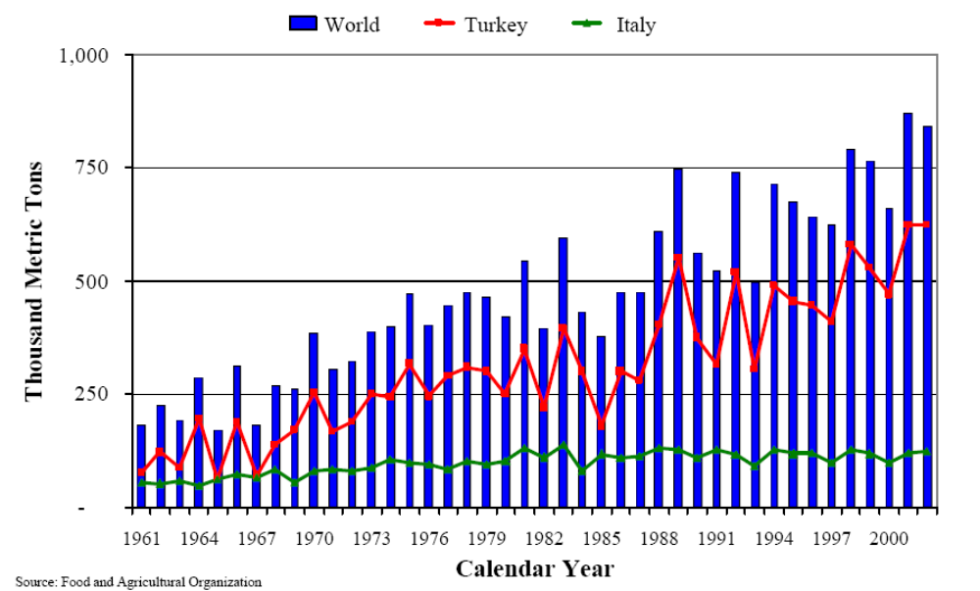

Due to the economic and social importance of hazelnut production in Turkey, the government provided price support and guaranteed purchases between 1964-2000. As a result of government intervention hazelnut prices increased, resulting in a large expansion of hazelnut cultivation areas with significant amounts of surplus product and stock accumulation. To control the accumulation of stocks, restrictions on hazelnut-planted areas have been implemented; however they have been ineffective in reducing plantation areas.

Turkey embarked on an ongoing structural adjustment and stabilization program towards the end of 1999. To reduce inflation and in accordance with the International Monetary Fund (IMF) commitments, the government prepared the Agricultural Reform Implementation Program (ARIP) financed by the World Bank (The World Bank, 2001). The aim of the ARIP is to reduce artificial incentives and governmental subsidies and to gradually convert the present support policies to direct income payments. As part of this reform, the price support system had been phased out gradually and the direct income payment system has been substituted, the compensation of $2000 per hectare is provided to farmers who voluntarily replace hazelnut with alternative crops in the flat areas. On the other hand, the government has given financial independence and administrative autonomy to the Union of Hazelnut Sales Cooperative. By means of the new policy arrangements, hazelnut price and producer income has been decreased and the effects of FISKOBIRLIK in the domestic market have been limited (Bozoglu, 2005). Domestic consumption is very low in Turkey. Turkish hazelnut export depends on the EU (especially Germany). About 65% of the export is comprised of raw kernels. Due to the high domestic prices in Turkey, hazelnut import from Georgia and Azerbaijan has increased since 2000. The imbalance in hazelnut market arises from the current unmatched between demand and supply conditions due to excess production.

This objective of this chapter is provided an overview of development policy interventions in the hazelnut sector and explain the effects policy interventions are having.

Factors Influencing Policy Intervention in Turkey’s Hazelnut Sector

Internal Factors
- Cultivation Area
There are approximately 536,000 hectares in production, although this is difficult to determine, given the lack of systematic crop surveys (Figure 7). The price support system in the hazelnut sector between 1964-2003 resulted in a 220% increase in hazelnut plantation areas. This increase was higher in the 2nd Standard Region due to higher productivity and farm size. Efforts by the Turkish government to reduce the area planted to hazelnuts have been ineffective due to a lack of grower interest (see section below).

- Yields
Hazelnut yield of Turkey is considerably lower than the major producer countries. In Turkey, the hazelnut yield is slightly higher than 100 kg per decare (Figure 8), which is 42% of the average yield in the United States, and 66% of Italy’s average yield in 2000-2003 (FAO and FISKOBIRLIK 2004). The reasons for low yield include: unsuitable soil conditions in the region, the large number of old hazelnut trees that require renewal, very tight planting of bushes, bare soil and high surface runoff (especially in the eastern Black Sea Region) and lack of input usage and other necessary caring activities (Bozoğlu 1999). Until now, there has not been any policy aimed at increasing hazelnut yield in Turkey. Prior to 1980, due to the young orchards, the yield in the 2nd SR were significantly higher than in the 1st SR, but the yield of the 2nd SR has decreased by means of getting older of hazelnut orchards. Turkey’s total yield has shown an insufficient increasing trend over the years. Therefore, there was an important fluctuation on yield (Figure 8). This caused instability on income of hazelnut producer.

- Hazelnut cultivation area in Turkey  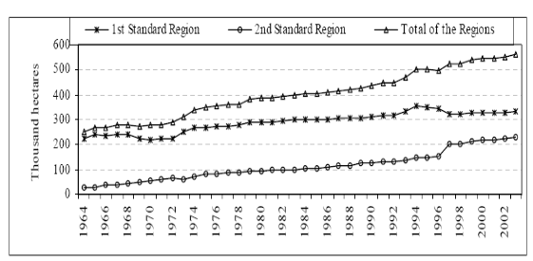  Source: (Bozoglu, 2005) | - Hazelnut yields in Turkey  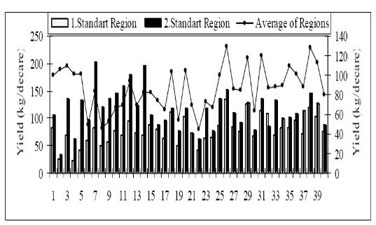  Source: (Bozoglu, 2005)

- Industry
Currently, there are 180 cracking firms with the annual capacity of 1.8 million tons as in shell basis, and 40 processing plants with the annual capacity of 350 thousand tons as kernel basis in Turkey (FTG 2004). There is about 65% idle capacity in the sector. The five largest processors account for an estimated 40% of production. The most part of industry is not vertically integrated and only a few firms participate at the various processing stages. Hazelnut producers sell generally their hazelnut as in shell since the beginning of September with respect to price levels and payment conditions to the private sector (local merchants, cracking plants, processing plants) or the HSCs members of FISKOBIRLIK.

- Consumption
In Turkey, total domestic consumption had increased until the beginning of the 1980s. After this period, domestic consumption was very stable. Domestic consumption is estimated about 70 thousand tons as snack foods and confectionary products. There had been an effort to promote consumption by granting and very low priced sales of FISKOBIRLIK’s stocks to the army and Ministry of Education in the past years. Nowadays the Hazelnut Promotion Group has made promotion campaigns to increase domestic consumption and exterior demand since 1996. Unfortunately, hazelnut prices in the domestic market are very high to increase consumption.

- Exports
Turkey accounts for more than 80% of the world hazelnut trade and, through FISKOBIRLIK, largely determines world export prices. Production level and price support policy applied by Turkey have largely affected on hazelnut export prices (Figure 9). Price instability is critical to Turkey’s hazelnut export. It disturbs the chocolate and candy industries, which use hazelnut as important input. In the long term, this state may decrease the use of hazelnut as input in the chocolate and candy industries.

FISKOBIRLIK had withdrawn gradually from the hazelnut export and recently hazelnut has been exported completely by the private sector. Although 78% of Turkish exports go to the EU, Turkey is trying to expand markets in Asia, the former Soviet Union countries, as well as the US, where it is involved in a joint promotion program with US growers to increase US hazelnut consumption. About 70% of Turkey’s hazelnut exports comprise raw kernels, with the remaining 30% being processed kernels, including roasted, sliced, chopped, paste, meal, and flour.

There was an increase on hazelnut export prices since the beginning of 2000s in Turkey’s favour. Whereas, export prices had decreased by means of the current hazelnut surpluses and policy applied by the Government. High production and large carryover stocks of Turkey resulted in low hazelnut prices in international markets. Low Turkish prices and large stocks in Italy and Spain encouraged the EU to somewhat limit Turkish hazelnut imports to allow Italy and Spain to eliminate their stocks (USDA 2003).

- Development of Turkish hazelnut export and export prices
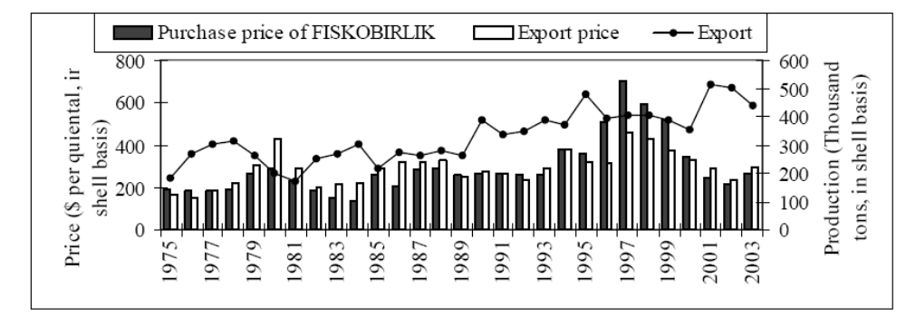
Source: (Bozoglu, 2005)

- Agricultural Policy Reform; From Price Support to Direct Income Support

Price Support System
Due to the economic and social importance of hazelnut production in Turkey, the government provided price support and guaranteed purchases between 1964-2000. FISKOBIRLIK (The Hazelnut Agricultural Sale Cooperatives Union) acted as the policy arm of the government by using the government’s funds to purchase and withdraw hazelnuts from the markets to help maintain prices. Between 1964-2003, FISKOBIRLIK bought on average 33.5% of Turkey’s hazelnut production (Figure 10). Government’s intervention was particularly important between 1964-1993, when FISKOBIRLIK purchased around 44% of domestic hazelnut production; overtime however the role of FISKOBIRLIK has decreased and limited to the purchase only of hazelnut surpluses.

- Purchase shares of FISKOBIRLIK
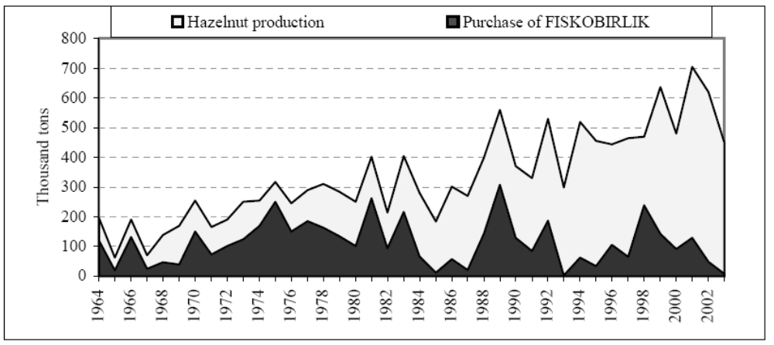
Source: Bozoglu (2005)

As a result of government intervention in the hazelnut market hazelnut prices increased and all growers benefited from this support system. However, purchase decisions were largely political and ignored market conditions (Bozoğlu 1999). Between 1975-2003, FISKOBIRLIK provided price support to hazelnut producers with an average margin of 40.4% over production costs, reaching 68% between 1994-2000 (Figure 11). Hence producers selling their hazelnuts to FISKOBIRLIK earned on average a net profit of US$ 0.42 per kilogram during this period, raising to US$ 1.03 per kilogram between 1993-2000.

- Hazelnut production costs and purchase price by FISKOBIRLIK
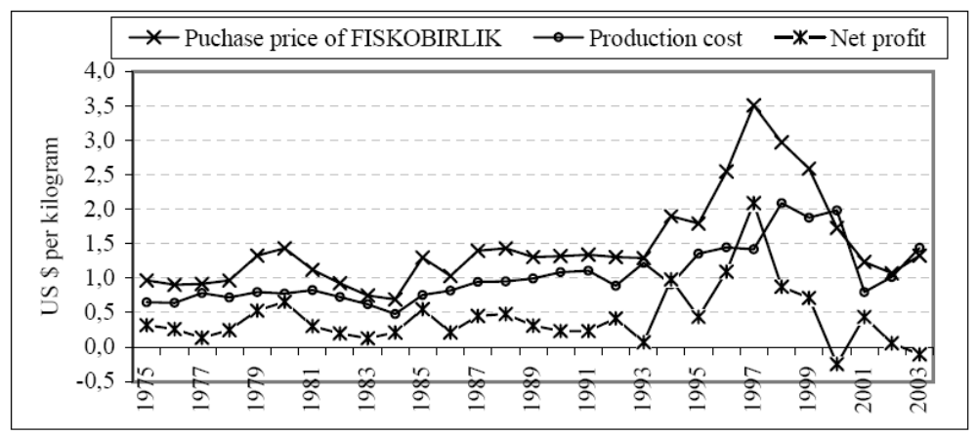
Source: Bozoglu (2005)

High support prices led to a large expansion hazelnut cultivation areas with significant amounts of surplus production and stock accumulation since the beginning of the 1980’s. Between 1964-2003, the price support system caused the hazelnut plantation to double and an increase of about four times in hazelnut production (Figure 12). Hazelnut areas have considerably expanded from 253 thousand hectares in 1964 to 563 thousand hectares in 2003. Hazelnut production has increased from 147 thousand tons in 1964-1966 to 592 thousand tons in 2001-2003. The increase in hazelnut plantation area and production within the 2nd Standard Region has been greater than in the 1st Standard Region. 65% of total increase in hazelnut plantation area and 55% of the increase in total production have occurred from the 2nd Standard Region. In addition, price support the relative ease of hazelnut production, which allows absentee landlords to stay in production, lack of suitable crops to replace hazelnut on steep slopes and forest regulation that allows horticultural production in areas that have lost forestry characteristics also caused increased of hazelnut plantation area and production (Bozoğlu 2002).

- Hazelnut cultivation areas and production in Turkey
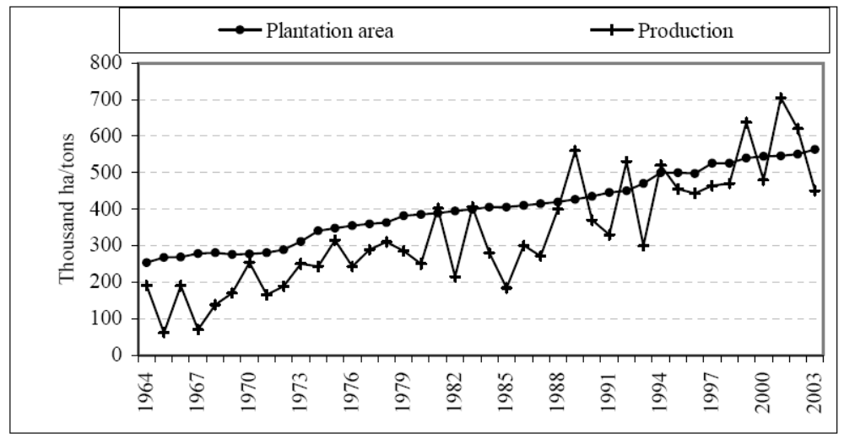
Source: Bozoglu (2005)

Hazelnut production has not been regulated in parallel to domestic consumption and export in Turkey. Therefore, considerable quantities of hazelnut stocks occurred in FISKOBIRLIK’s stores in the past years. During the 1982-2003 period, FISKOBIRLIK’s average stocks were 107 thousand tones as in-shell hazelnut. Due to the state’s support policies and the fluctuation of hazelnut production, the stocks increased to over 200 thousand tons in some years (Figure 13). In order to regulate market prices, excess hazelnut has been purchased by FISKOBIRLIK. This has required the financial aid of the government at a very high cost. Surplus hazelnut purchased by FISKOBIRLIK could not be sold. In this respect, the credit used by FISKOBIRLIK could not been returned to the Government. FISKOBIRLIK incurred losses due to using overripe hazelnuts as oil. This loss was incurred instead of credit being taken by the Government (TT 2004). It is estimated that $ 150-200 million is being wasted each year for hazelnut oil production. The treasury has covered FISKOBIRLIK’s losses so far (WB 2004).

- Hazelnut stocks of FISKOBIRLIK
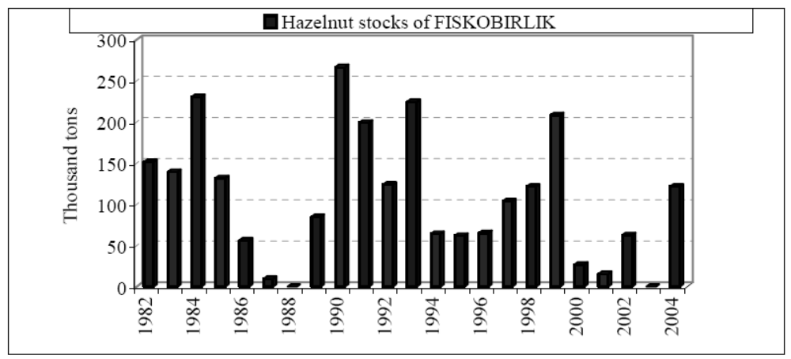
Source: Bozoglu (2005)

- Restrictions on Planted Areas and Payment for Alternative Crops
To control the accumulation of stocks, restrictions on hazelnut-planted areas were implemented in 1989 by enacting a new regulation. This regulation restricted hazelnut-planted areas to areas that are less than 750 m above sea level, with at least a 12% slope, and composed of 4th or higher class soil, excluding some specified areas. Despite this regulation, hazelnut production continued in forbidden areas. An additional regulation enacted in 1995 provided a program to pay producers to convert hazelnut-planted areas having young trees to alternative crops. Lack of funds, however, has prevented this regulation from being implemented.

The Agricultural Reform Implementation Program
To reduce inflation and in accordance with the International Monetary Fund (IMF) commitments, the government prepared the Agricultural Reform Implementation Program (ARIP) financed by the World Bank (The World Bank, 2001). The aim of the ARIP is to reduce artificial incentives and governmental subsidies and to gradually convert the present support policies to direct income payments. The ARIP encompasses four main initiatives. The first one is to gradually phase out existing support policies (price support, input and credit subsidies) and replace them with the direct income support system (DISS) for poorer farmers. The second is the Farmer Transition Program (FTP) for hazelnut, tobacco and tea. The third is the Restructuring of the Agriculture Sales Cooperatives (ASCs) and Cooperative Unions (ASCUs), and the fourth is the Public Information Campaign (PIC) for the ARIP (ABGS 2004).

The Direct Income Support System
The strategy for implementing the DISS over the 2000-2005 period was adopted and announced by the government in 2000. The objective of this component is to provide some compensation for income loss through removal of input subsidies and price supports. In line with this strategy, a pilot project for the DISS was began in four selected regions in 2000 and the government gave the farmers $ 5 per decare as a direct income payment. The program had expanded to all the country and all input and credit subsidies had been eliminated by 2002. The ASCUs have given members lower prices since 2000. In 2003, the amount of direct income payment was increased about TL 16 million per decare ($ 11 per decare). However, the DISS compensated almost half of the income loss imposed on Turkish farmers by the cuts in agricultural subsidies in the period of 2000-2002 (WB 2004).

In line with this strategy, FISKOBIRLIK has applied low price and purchased specific quantity of hazelnut, which can sell in the market policy not more than can sell since 2000. During the 1975-2000 period the average price support for hazelnut varied from 40,4 percent to 68 percent over its production cost, but this was decreased to 1,3 percent in the 2001-2003 period. In a parallel to this development, the purchase share of FISKOBIRLIK has decreased considerably from 40 percent in the 1964-2000 period to 10 percent in the 2001-2003 period.

The Farmer Transition Program
The World Bank is also supporting the FTP. The aim of the FTP is to help farmers make the transition to alternative activities while governmental supports are reducing. Some funds were provided for farmers to replace hazelnut orchards on the 1st and the 2nd class land and the 3rd class land with a slope below 6 percent, with alternative crops such as corn, corn for silage, sunflowers, vegetables, soybeans, canola, vetch, fodder crops, alfalfa, strawberries and other berries, kiwi fruit, rose hips, traditional fruits, garlic, aromatic and medical plants, etc. Hazelnut areas on hills and slopes, where the ecology generally does not allow economic production of other crops, were not included in the FTP (WB 2002). Within the scope of the FTP, it is estimated to grow alternative crops on 16 thousand hectares of flat areas in the Black Sea Region. In 2002, the Government suggested paying an amount of $146 per hectare for the cost of inputs and the loss of income due to the switch from hazelnuts to an alternative crop for a year. Then, the amount of payment was increased to about $2.000 per hectare due to encourage conversion more producers to involve in this program (TUGEM 2004).

The program has been adopted by only a small number of farmers. Up to the beginning of March 2003, only 837 producers applied this project for uprooting 1.163 hectares of hazelnuts, which is equal to 7,2 percent of the targeted area. This effort by the Government to reduce the hazelnut plantation area has been ineffective due to lack of grower interest. There are some difficulties for the FTP as follows: hazelnut is the main income source for most producers, insufficient compensation to grow alternative crops-Demiryurek and Bozoğlu (2002) determined that the compensation amount of producers’ request is higher about nine times than the present amount of compensation- living in other places and working in other sectors by some growers, ease of growing hazelnut and the requirement of less labour, worry about obtaining insufficient income from alternative crops and possible marketing problems of alternative crops, lack of public information campaigns by the ARIP, lack of grower interest and reluctance irrigation infrastructure at flat areas, absence of agro-food industry on alternative crops (TUGEM 2004).

The Restructuring of the Agricultural Sales Cooperatives and Cooperative Unions
In order to stop the policy of high price and excessive employment applied by the ASCUs and to prevent further burdening of the public budget, the Act numbered 4572 regarding about the ASCUs was adopted in 2000. This Act has given financial independence and administrative autonomy to the ASCUs. Beginning of 2001, the ASCUs have not been eligible to receive annual allocations or other subsidies from the fiscal budget. The ASCUs have been restructured to function as effective cooperatives owned and operated by and for the members. The law eliminates all preferences and the government’s role in the operation of the ASCUs, and establishes a framework for carrying out their restructuring into private cooperatives. The restructuring of the ASCUs will be carried out by the end of 2005, by decreasing the number of workers and excessive wage costs, and focusing on their core businesses (DPT 2001).

The restructuring of the ASCUs will contribute to the transformation of the ASCs into genuine cooperative organizations which are member-controlled and operate in accordance with needs and priorities identified by their members, efficiently managed and able to provide effective services to their members and, competitive and self-reliant and thereby able to operate in competition with other private sector enterprises without having to depend on government subsidies and supervision (WB 2002).

However, in 2000, as a transitional measure, some credit (250 trillion TL) has been made available from the budget to the ASCUs until the time that they are sufficiently self-financing and sufficiently creditworthy to obtain working capital loans from commercial banks (WB 2002).

Now, FISKOBIRLIK is not authorized by the government to purchase hazelnut at a loss. Growers maintain political pressure to provide price support. FISKOBIRLIK has requested but not received any fund from the government for hazelnut procurement. Instead, FISKOBIRLIK purchased a small amount of hazelnuts with its own funds and plans to cover the purchasing costs.

FISKOBIRLIK has 50 cooperatives and about 250 thousand farmers are members of cooperatives. When the law of 4572 was enacted, FISKOBIRLIK and the Hazelnut Sales Cooperatives had 2499 employees. FISKOBIRLIK has applied to retrench workers in order to eliminate excess labor and achieve wage parity with its private sector competitors. A total of 1.038 workers were subject to leave or retrenchment at the end of April 2004. The Restructuring Board advised the decrease of the current staff to 925 (FISKOBIRLIK 2004). Following retrenchment, any replacement workers will be hired at wages equal to those paid by the private sector. In order to make the transition successful, cooperatives need a comprehensive range of support services over a comparatively long period of time (WB 2002).

The Public Information Campaign
The aim of the PIC is to provide accurate and timely information about the reforms and describe the support mechanisms available under the project to farming communities through television, radio and newspaper announcements (WB 2002). However, the PIC has not been sufficiently applied by the Ministry of Agriculture and Rural Affairs. Half of hazelnut farmers on the illegal areas have not received information about the alternative crop program (Demiryurek and Bozoğlu 2002). This situation has a negative effect on the ARIP.

Conclusions
Due to the current hazelnut surpluses, continual problems on farms, the financial problems of FISKOBIRLIK and international commitments of Turkey with the IMF, hazelnut policy was been forced to change. The hazelnut policy reform has brought fundamental modifications to the hazelnut market. However it is not expected that the reform program can adequately solve the current problems of hazelnut market. Conversely, it is expected that the reforms will negatively affect hazelnut growers, FISKOBIRLIK and the markets in the short and middle term. Thus, the reform measures, which were decreasing hazelnut growers’ income and also income stability of hazelnut growers, were stopped. In the future, probable huge surpluses will decrease hazelnut prices in Turkey and other producer countries may be negatively affected from this issue. Nevertheless, compensation payment given for uprooting hazelnut in the flat areas is proven ineffective and will not reduce hazelnut surpluses at the current rate. The real interest rate is very high in Turkey and this state limits to take credit of FISKOBIRLIK from the private banks. However, most of hazelnut producers still expect high price form FISKOBIRLIK.

The aims of the hazelnut policy focus on obtaining market balance, increasing yield and quality of hazelnut, organizing farmers effectively, increasing and stabilizing the income of farmers who become organized, expanding domestic and foreign consumption of hazelnut. In order to achieve these aims, not only market problems but also the structural problems of hazelnut farms must be solved. The government must control the plantation restriction in the flat areas and give higher compensation for uprooting hazelnut in the flat areas. However, the real interest rate must be decreased and the members of cooperatives should invest capital in their cooperatives. The government must give income guarantee to farmers who become organize, increase productivity and quality of hazelnut and, apply low environmental impact agricultural practices. The government must also take measures to develop some stock exchanges (there are convenient situation in Ordu, Giresun and Trabzon) for hazelnut in the Black Sea Region. All these measures can help solve the current problems of hazelnut market in Turkey.

MOROCCO AGRICULTURAL SECTOR

Introduction
Agriculture (including fishing) accounts for 14% of Morocco’s GDP (2006), provides 40% of total jobs, and accounts for almost all employment in rural areas, where half the country’s population lives (Oxford Business Group, 2007a). Agriculture represents around one-fifth of exports, yet the export potential is by all accounts insufficiently exploited, and imports are growing as tariffs fall (Oxford Business Group, 2004).

Horticulture is one of the most relevant sectors of Morocco’s agriculture. In addition to its economic importance, the sector is also socially important, accounting for a high share of rural employment. The land currently dedicated to fruit and vegetables in Morocco surpasses 700,000 ha, or 56% of the 1.25m ha of the country’s irrigated arable land (Oxford Business Group, 2007a). Average production tops 7m tonnes annually – 4m tonnes of vegetables and 3m tonnes of fruits (Oxford Business Group, 2007a).

The vegetable sector, despite its long-standing export orientation, experienced a significant change in 1986 when the national export monopoly was liberalized. The EACCE (Etablissement Autonome de Contrôle et de Coordination des Exportations - Public Export Control and Coordination Authority) was then established to control and ensure compliance of Moroccan fresh produce exports with international and bilateral regulations regarding both quantity and quality standards. Furthermore, it functions as an important source of information for Moroccan producers, processors and exporters. Since its establishment many producers started production and tomato production increased considerably, from an average of 355,000 tons during the period 1990-1995 to 524,000 tons in 1996-2000 (+48% increase). During the crop year 2001-2002, it reached 565,000 tons, a 28% increase relative to the year before (446,000 tons). This production represents 51% of the total production of early vegetables (Azzouzi, Laytimi, & Abidar, 2007). Moroccan tomato exports have increased from an average of approximately 150,000 tons in 1990 to more than 200,000 tons per year in 2006 which represent almost 20% of total fresh tomatoes production (Codron, Bouhsina, Fort, & Rouvière, 2007).

The objective of this chapter is to provide an overview of an USAID funded project, the Integrated Agricultural and Agribusiness Project, aimed at increase the global competitiveness of Morocco’s agricultural sector through activities in agricultural policy and institutional development, production and processing of agricultural products and the development of support services.

Factors Influencing Policy Intervention in Moroccan Agricultural Sector

Internal Factors
- Water
Water is a key binding constraint in increasing Morocco horticultural production. Roughly 16% of the cultivated areas are irrigated, about half with modern equipment. While there is some potential to expand irrigated areas, but it may be at high cost. The irrigated sector consumes about 85% of the country's total available water supplies (Diao, Dinar, Roe, & Tsur, 2007). To help improve water efficiency, the World Bank granted Morocco a $100m loan on May 1, 2007. Yet this is not expected to change Morocco’s semi-aridity.

Besides the uneven geographic distribution of the country’s water resources, an uneven and erratic rainfall pattern persists with large year-to-year fluctuations from the arid South to the Northern regions. This erratic pattern places pressures on the extraction of ground water using largely imported energy, and thus accounts for the shock to ground water cost. In addition, high population growth over past decades has led to reduction of farm sizes and extension of the agricultural frontier into forests and rangelands that are often unsuitable for crop production and prone to erosion and soil degradation.

- Land Fragmentation
With the exception of a few modern and well-managed farms, most of which are owned by the private sector, the country’s farms are notoriously fragmented. Intricate succession laws weigh on the outlook for the aggregation of small farms. According to the Ministry of Agriculture, among the 1.5m plantations in the country, about 22% cover less than 1 ha, 53.2% less than 3 ha, and 87.1% less than 10 ha. This fragmentation of farming areas, not only precludes farmers from adequate financing but also greatly reduces productivity.

The fact that the state’s special financing arm, CAM, is the only bank in Morocco to grant credit to the sector is testimony to its lack of profitability. The country’s banking act of 1993 established the universal banking concept. Although CAM diversified its operations
and now provides loans ranging from mortgages to consumer credits, its 13 competitors remain reluctant to grant credit to farmers for what they see as a high-risk segment in which few borrowers have the collateral required to secure a loan (Oxford Business Group, 2007a).

- Factors of Production
In addition to fertile land, one of the most important strengths is its production costs. For instance, wages in the agricultural sector sector are quite low. The government’s financial concessions contribute to lowering production costs. The sector has not been subject to either direct or indirect taxation for more than three decades, and in 2000 parliament extended the exemption to 2020 (Oxford Business Group, 2007a). Equipment and infrastructure are also tax-free in a bid to encourage farmers to invest more in production factors. The move somewhat contributed to the extensive use of greenhouses. Combined with Morocco’s mild Mediterranean climate, greenhouses improve productivity of fruits and vegetables. With the by far biggest phosphates reserves in the world, Morocco has an abundance of fertiliser. Despite this, however, average use of fertilisers remains low by international standards, with Morocco consuming just 45 kg per ha on average, as compared to 288 kg in the UK, 225 kg in France and 161 kg in Spain.

Fruit and vegetables offer higher returns to land and water than field crops such as cereals that have historically dominated Morocco agriculture, and MENA region in general. Table 16 illustrates the scope for increasing the return to water use by shifting from the irrigation of cereals to horticultural crops in the MENA region irrigation systems.

- Returns to water use in the MENA region, by crop
Product | Water  (m³/ton) | Revenue  (US$/ton) | Return to water use  (US$/m³ water)
Vegetables | 1,000 | 500 | 0.50
Wheat | 1,450 | 120 | 0.08
Beef | 42,500 | 2,120 | 0.05
Source: (The World Bank, 2003b)

High value export crops also generate more employment than do traditional crops such as cereals. Cereal crops tend to have low labour requirements, particularly when modern farming techniques are applied. Fruits and vegetables, however, have far higher labor requirements. Figure 14 shows that horticulture in Morocco requires nine times more labor than traditional cereal farming.

- Labour requirements of Moroccan agriculture
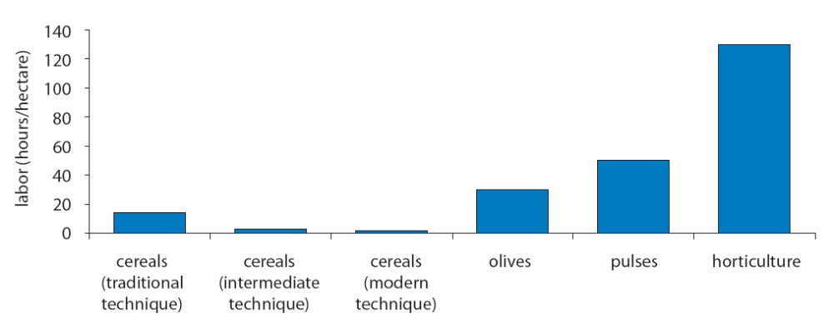
Source: (The World Bank, 2007)

- Compliance with international quality and safety standards
The ability to comply with international standards on food quality and safety and on product traceability is key to improving Morocco’s international competitiveness. The number of Eurepgap-certified producers in Morocco has increased significantly in recent years. Currently 207 out of 600 tomato producers are Eurepgap-certified (Chemnitz, 2007).

In addition to better labelling and packaging standards, Morocco needs to improve the sector’s handling processes. Conforming to European standards on pesticides should be given special attention. In 2006 the Health and Consumer Protection DG of the European Commission found above-average residuals of pesticides in Moroccan mint (DG (SANCO), 2006). Morocco’s pesticides do not always conform to international norms, as the country currently stores an estimated 700 tonnes of unusable, obsolete chemicals. Morocco has receive a $4m grant in the framework of the UN Environment Programme in order to help destroy the stockpile of outdated pesticides.

External Factors
- Trade Agreements
In addition to being a member of WTO, Morocco has entered into several bi-lateral and regional trade agreements. In 1995, it entered an Association Agreement with the European Union, but that agreement excluded agriculture. Since then there has been some opening in agriculture. The last negotiation was completed in 2003 and gives Morocco preferential access to European markets for several agricultural products (90% of Morocco fruit and vegetable exports to the EU are conducted under preferential access conditions) (Jacquet, Petit, Tyner, & El Hadad, 2007), in particular tomatoes during the production period distributed month per month from October to April. The tomato quota increased from 156,000 tons to 220,000 tons in 2007. The minimum entry price for Morocco is considerably lower than for other countries and Morocco has continually increased tomato production as the quota has expanded. However, there are problems in managing the quota since it is month by month with some provision for rolling over a small part of the monthly quota if it is not met. In 2005, however, Morocco exported only 60 percent of the available quota, which amounts to lost revenue of US$44 million, with resulting effects on rural livelihoods.

The Integrated Agriculture and Agribusiness Program
The Integrated Agriculture and Agribusiness (AAD) Program is a five-year initiative by USAID Morocco to increase the global competitiveness of Morocco’s agricultural sector through activities in agricultural policy and institutional development, production and processing of agricultural products and the development of support services (Chemonics International Inc., 2005b). The program began in February 2005 and has its origin in the Free Trade Agreement concluded between the US and Morocco in 2004. The requirements of this agreement, and other similar commitments to trade liberalization by Morocco, require a general upgrading of the country’s agricultural capability that this program is designed to facilitate through its market-led approach.

The program has the following key objectives:
- To improve the capacity of Moroccan agriculture, agribusiness, and related support industries to compete in local and foreign markets through targeted interventions in four major areas:
1. Public policy and supporting institutions;
2. Agriculture and livestock production;
3. Agro-processing;
4. Other agribusiness and supporting industries.

- Through increased competitiveness in the global marketplace, contribute to the creation of jobs and increased incomes for farmers, workers and other entrepreneurs, especially in rural areas, smaller towns and cities.

Program Activities
The program focuses its activities in three regions of Morocco with a wide range of crop and livestock systems that are broadly representative of the country’s major agricultural production regions: the Loukkos/Gharb perimeters, Saïs and Oriental. The program may also develop activities in other parts of the country in order to complement activities initiated in the above regions.

The identification of potential partners, both public and private, within each region was an important phase of the program start-up. The main partners who will be seated in the regional support committees were identified through the regional workshops. Partners meetings were held in the regions with both the public and the private sectors. Program objectives and orientations were presented and discussed. Reconnaissance tours within the regions were done to give the program team ideas on the crops grown and the potential for introducing or improving other crops. Visits to some agro-industries and local professional organizations were undertaken to discuss interventions within some specific filières.
On the basis of these visits and preliminary analysis, the program intends to focus its support on higher-value crops through improved cultural practices, improved quality control in packaging and processing, and assisting associations develop better market linkages and provide other effective services to their members.
Regional workshops were held in each region where regional key players, both public and private, were invited. The objectives were to present the program to the regional stakeholders, to validate the filière chosen for the first 2 years of program activities, to discuss the composition of the regional support committees and to design specific activities within a set of pilot projects that will be implemented within each filière.
These activities are designed to strengthen filière linkages along the chain to ensure closer coordination among producers, agro-processors and the market. The filières that were identified and validated for each region are reported in the table below.
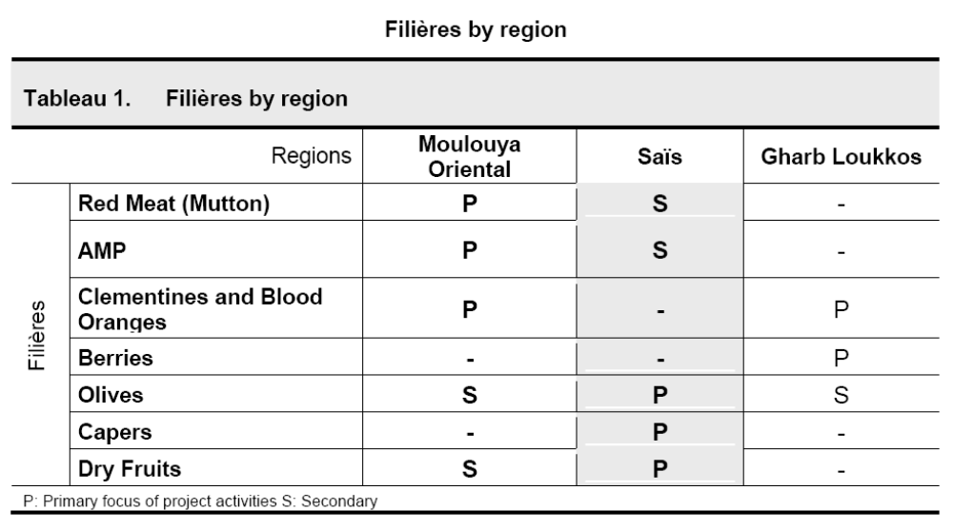
Source: (Chemonics International Inc., 2005b)

In defining the target filières the following factors were considered:

- The economic importance of the filière in the three target regions based on
  - the hectares of product farmed in our target regions,
  - the number of farmers engaged in production
- The potential for productivity and quality increases within the life of project
- The potential for improving value-added and marketing activities
- The potential for export into new markets
- Widespread interest in the crop and the potential to achieve positive economic results over the short to medium term.
- The competitiveness of the crop, either in world markets or in the national market, coupled with the potential to improve this during the life of the Project.

Using these criteria, assistance to cereal and sugar industries was ruled out, allowing a more business-oriented and world market sensitive approach to be fostered.

The choice of filières poses a number of opportunities to act along the entire length of the value chain to improve production, quality (including traceability and certification), processing, marketing and the policy issues that constrain the filières at various levels. Depending on the filière, actions will be focused on the weakest links first, to achieve rapid results. Nonetheless an integral approach has been validated through the regional meetings, and the project will be addressing issues from availability of planting material and nurseries all the way through new value-added forms of product targeted at hitherto under-exploited markets. This is planned to also integrate strengthened associations and business development services, coupled with enhanced and more transparent market information systems.

Project Impact
Only a progress report for the first 7 months for the project lifetime (Feb-Sept 2005) is publicly available (Chemonics International Inc., 2005b); hence it is impossible at this stage the impact of the project on the target commodity groups. However, early activities are starting to have an impact:

- Market Information: The program is working with the Etablissement Autonome de Contrôle et Coordination des Exportations (EACCE) to improve its ability to inform producers of international market opportunities and trends through the development of a network of market observatories.

- Production of traceability guides for frozen strawberries and for capers during the third and fourth quarters of the year in response to a request by the Fédération des Industries de la Conserve de Produits Agricoles Maroc (FICOPAM).

- Numerous assessments of Morocco’s market position in table olives, olive oil and capers have been carried out. Opportunities for value adding identified in Morocco’s established caper industry, which currently exports in bulk. The project also responded to a number of demand-driven requests for information, linkage to suppliers and potential investment in Morocco.

Conclusions
While the countries included in this review are facing similar challenges related to structural and chronic problems (i.e., drought, modest agricultural growth rates, limited rural infrastructure and natural resource base, bias in favor of urban areas, land tenure and property rights), the range of opportunities depends not only on how the future of their agriculture is perceived but also on other economic development issues such as diversification within and outside the agriculture sector, macroeconomic performance and the role of the state in the economy.

The review of the different policy intervention in the studied countries suggests a number of common factors as key determinants of successful agricultural development:

- Financial and technical assistance: the support provided by the international donor community and development financial institutions has been critical to the success of reviewed intervention policies. International expertise in citrus certification provided by the Citrus Improvement Program (CIP) in Egypt and the application of new technologies by the leading producers and nurseries were essential to convince farmers of the potential of quality planting material, even at considerably higher prices. Technical assistance and grant support from USAID has been instrumental to HEIA’s success in improving the performance of the Egyptian horticultural sector. However, questions have been asked regarding the long term sustainability of development initiatives once outside support is withdrawn. Achieving sustainability may require a long-term commitment. HEIA faces a struggle to continue its services and fees for most services would have to be increased by well over 100%, which will put them out of the reach of many members. This would have a severe negative impact on Egyptian horticulture export performance and would jeopardize the sector’s competitive advantage in international markets.

- Investment in transformation and knowledge systems: Training is fundamental since specific experience and know-how in terms of production and post-harvest are lacking. The MHAP in Jordan has established a consortium of agribusiness companies to (i) develop a pilot demonstration farm in key locations to apply advanced production techniques, (ii) establish a production, processing and export business based on contract farming system for the benefit of other small and medium producers. Pioneer producers from the consortium receive special technical support and promotion from the project.

- Market-oriented culture: value chain development initiatives are likely to have a greater, long-term impact if they target/involve producers, exporters or business organisations with a market orientation. Their awareness of market requirements, both at home and export markets, would act as key drivers for cooperative arrangements and greater ownership of development initiatives. Moreover, potential benefits derived by linking producers to markets, particularly markets where producers and exporters may develop a sustainable competitive advantage, will generate the market incentives for project participation and project ownership. HEIA emerged from the association of 25 horticultural producers who recognised the need for a forum to share information on technology for their horticultural operations, equipment and packaging.

- Size factor: Market orientation and entrepreneurial culture in developing countries, however, tend to be highly correlated to farm or business size. Low human capital and lack of financial resources among small producers hinder their participation in development initiatives.

- Selection of sectors/chains (picking the winners): the selection of products based on demand factors (export markets) alone is unlikely to have a major impact on poverty reduction and rural development, as clearly demonstrated in the Egyptian case studies. The two intervention policies have been instrumental to the process of expanding the production and export of a limited number of Egyptian horticultural products (i.e., high value crops and citrus fruits). Future intervention activities in the horticultural sector, however, should cover the entire sector, not just export horticulture, because (i) exports are likely to remain a fairly small percentage of overall volume marketed (currently only 3.5% of Egypt’s horticultural production is exported), (ii) upgrading domestic production and marketing solidifies the foundation for exporting, and (iii) fresh produce feeds into and complements processed produce. A ‘multi-chain’ approach is likely to have a greater impact as illustrated in the case of Morocco, where the program focuses its activities in three regions of Morocco with a wide range of crop and livestock systems that are broadly representative of the country’s major agricultural production regions.

- Enabling business environment: the liberalization of markets and opening of agri-food industries to private companies has led to more responsive supply chains to market requirements, as illustrated in the Tunisian olive oil sector. Although still restricted, the opening up of the market has led to a considerable improvement in the marketing of the country’s olive oil. This has enabled private firms to explore new markets, thereby diversifying Tunisia’s client base by exporting to emerging markets. Although the quantities exported to these markets remain limited compared to exports to the EU market, this orientation requires support. Hence, there is a role for the government to develop value chain initiatives and infrastructure in support of the private sector aimed at increasing their competitive advantage in export markets, including market information, technical, business and financial services, quality certification, risk mitigation and support infrastructure.

- Establishing links between all relevant actors in the value chain: extensive dialogue and coordination is required to maximize the impact of intervention policies. Building of partnership between small, medium and large producers, exporters and processors is crucial for a functioning marketing. The MHAP in Jordan shows that specialized training and awareness sessions are necessary to mobilize and commit target producer groups, including farmers, supervisors, laborers, middlemen, and transport agents to the standards of performance necessary to ensure that initial export quality is maintained until reaching the consumer. Fresh herbs are very sensitive commodities that require special care to maintain quality along the market chain leading to the final consumer. The identification of potential partners, both public and private, within each region was an important phase of Morocco’s Integrated Agriculture and Agribusiness program start-up. The main partners who will be seated in the regional support committees were identified through the regional workshops. Partners meetings were held in the regions with both the public and the private sectors. Program objectives and orientations were presented and discussed. Reconnaissance tours within the regions were done to give the program team ideas on the crops grown and the potential for introducing or improving other crops. Visits to some agro-industries and local professional organizations were undertaken to discuss interventions within some specific filières.

- Screening of participants: Willingness is the most important characteristic in farmer selection. Financial capacity and readiness to invest in a new idea are often not enough to make the exports successful. Unfortunately, willingness is not easily quantified or screened; therefore, contractual agreements are needed to insist on the stringent requirements of the export market. These requirements cannot be left to farmer discretion.

- Coherent and realistic policies: Hazelnut reform policy in Turkey has not had the expected results with the Farm Transition Programme being only adapted by a small number of farmers due to the lack of interest (7.2% of the targeted area). Insufficient compensation to grow alternative crops in making the policy ineffective and will not reduce hazelnut surpluses at the current rate. Moreover, the lack of public information campaigns to provide accurate and timely information about the reforms and describe the support mechanisms available under the project to farming communities has not been sufficiently applied by the Ministry of Agriculture and Rural Affairs. As a result, half of hazelnut farmers on the illegal areas have not received information about the alternative crop program.

Table 17 presents a comparative summary of similarities and differences in the pattern of intervention and their relative level of success of each policy intervention.

- Similarities and differences in the pattern of intervention and their relative level of success.

 | Target | Intervention Drivers | Objective | Intervention Approach | Impact | Success factors | Challenges
Egypt
HEIA | High-value, non-traditional export crops with good market growth potential: (grapes, strawberries, melons, green beans, cut flowers, mangoes) | - Exports of target products were in declined while all other horticultural exports were expanding  - Limited cooperation between horticultural export companies  - Lack of planning of export quantities and quality requirements | Increase horticulture export performance, though:  - improvement of quality production  - marketing  - policy advocacy  - training and management | - Private initiative built on a previous export facilitation USAID project (ATUT)  - Outside financial support (USAID) | - Significant role in expanding Egypt’s horticultural exports (93% to 108% increase)  However focus on a few high value, high-technology crops accounting for a small % of Egypt’s total horticultural and agricultural exports (6% and 2%, respectively)  - Only 3.5% of horticultural production is exported | - Substantial grant support and assistance from other USAID partner activities  - Private initiative by large exporters: marketing oriented/entrepreneurial culture | - Funding of activities/services: HEIA has to find ways to continue its services with drastically reduced levels of outside support. Fees for most services would have to be increased by well over 100%, and this would place them out of the reach of many members.  - Increase smallholders membership (Middle and Upper Egypt). HEIA’s services will have to be restructured to overcome the logistic problems posed by farmers who may be illiterate or have limited access to transportation. In addition, many smallholders would be able to bear the full cost of HEIA’s current services.
CIP | Citrus | - Low productivity due to inappropriate cultivation practices and graft-transmissible diseases  - Low export prices  - Low penetration in EU premium priced quality conscious market (< 10% exported volume)  - Lack of processing facilities | - Improve the competitiveness, quality and export potential of Egypt’s citrus fruits  - Establish a monitoring and certification system that enables seed production and quality control at levels consistent with international standards | Development of a common strategy for the sector with participation of all relevant stakeholders, both public (MALR) and private (nurseries, growers and exporters, and international donors (GTZ) | - Improvement in planting material  - Certification scheme with strict regulations for the citrus nursery sector  - Increase in yields (12 tons per ha of exportable fruit)  - Increase in benefits for the sector  - 6% of total Egyptian orchards planted with citrus by 2020. | - Financial and technical assistance by GTZ  - Involvement of all relevant stakeholders  - Application of new technologies by the leading producers and nurseries were essential to convince farmers of the potential of quality planting material, even at considerably higher prices  - Favourable economic framework conditions (heavy investments of the private sector in new plantations in the desert and the devaluation of the Egyptian currency) have helped on the demand side for improved planting material and led to increasing export volumes of fresh fruits. | - Long term sustainability once outside support comes to an end

 | Target | Intervention Drivers | Objective | Intervention Approach | Impact | Success factors | Challenges
Tunisia
National Programme to Promote Package Olive Oil Exports | Olive oil | - 99% of Tunisian live oil exports to the EU is in bulk, which deprives Tunisian exporters of the value added  - Product differentiation (Tunisian mark) | Increase the percentage of olive oil that is conditioned in Tunisia (with a Tunisian brand) and then sold to wholesales from the current 2% to 10-20% within three years. | Funding of marketing activities (70% of the cost of actions of common interest, and to 50% of the cost of specific actions, with a ceiling of 70 thousand Dinars per year and per enterprise) | - Increasing export opportunities to emerging markets (US) | - Liberalisation of the market  - Responsive private sector | - World market dominated by EU growers which received production aids  - Concentration of Tunisian olive oil exports on the EU market  - The quantities of packaged olive oil exported at present are only 1% of the total olive oil exportations  - Increasing demands for stringent quality and marketing standards and requirements (traceability, labelling, packing, etc.)
Promotion of Organic Olive Production | Olive oil | - Increasing demand for organic agri-food products | Develop a competitive edge in the EU market for organic olive oil | Subsidies for equipment, certification, research, training, farm associations and marketing | - Increasing production and export quantity | - National Regulatory Framework for Organic Agriculture | - Growth is limited by conditioning process  - Poor soil fertility and structure (import of organic matter remains prohibited)  - Lack of domestic demand (export focus)

 | Target | Intervention Drivers | Objective | Intervention Approach | Impact | Success factors | Challenges
Jordan
Conservation of Medicinal and Herbal Plant Project | Fresh herbs | - Poor level of diversification in the agricultural production systems.  - Low net return per unit area from traditional crops.  - Increasing number of small-size holdings due to land fragmentation.  - Increasing area of small-size holdings not cultivated.  - High economic returns from cultivating medicinal and herbal plant  - Increasing international market demand.  - Low quality products, lack of good post-harvest processing and handling, poor packaging and transportation | - To develop models for conservation and sustainable use of herbs for national and global interest  - To promote production of herbs with the aim of improving incomes and livelihoods of the rural poor  - Diversify agricultural production systems.  - Increase net return per unit area.  - Create new job opportunities at farm level. | (i) in situ conservation of herbs  (ii) promotion of production including R&D of best agricultural practices,  (iii) capacity building for human resources including awareness, higher education and training  (iv) commodity promotion including intellectually property rights standards and specifications, legislations, and marketing. | - Improved quality of herbs to the local market  - Exports to Europe are increasing in volume and variety  - Increase in producers income | - Financial and technical assistance by international donors  - Specialized training and awareness sessions to demonstrate feasibility of production and to attract private investment  - Establishing linkages between all actors in the chain  - Willingness is the most important characteristic in farmer selection to participate in the project  - Contractual agreements are needed to ensure compliance with stringent requirements in international export market | - Consolidation of incipient investments  - Establishment of sustainable business relationships with international buyers.  - Potential saturation of the market  - Lack of infrastructure to channel new production volumes to the export market

 | Target | Intervention Drivers | Objective | Intervention Approach | Impact | Success factors | Challenges
Turkey
The Agricultural Reform Implementation Program | Hazelnuts (agricultural products) | - Market balance  - Increase yields and quality  - Organise farmers effectively  - Increase and stabilise income  - Increase domestic consumption and exports | - Gradually phase out support policies (price support, input and credit subsidies) and replace them with the direct income support system for poorer farmers  - Farmer Transition Program (FTP) for hazelnut, tobacco and tea.  - Restructuring of the Agriculture Sales Cooperatives (ASCs) and Cooperative Unions (ASCUs)  - A Public Information Campaign to inform farmers about the reforms and support mechanism | All input and credit subsidies have been removed. Farmers have receive some compensation for income loss  Financial support for farmers to replace hazelnut orchards with alternative crops | - The conversion program has been adopted by only a small number of famers (7.2% of the target area in 2003)  - Fall in growers’ income  - Increase in hazelnut surpluses | - Failure due to the lack of grower interest (hazelnut is the main income source for most producers, insufficient compensation to grow alternative crops)  - Half of hazelnut farmers on the illegal areas have not received information about the alternative crop program | - Product surpluses will decrease hazelnut prices in Turkey and other producer countries  - Compensation payment given for uprooting hazelnut in the flat areas is proven ineffective and will not reduce hazelnut surpluses at the current rate

 | Target | Intervention Drivers | Objective | Intervention Approach | Impact | Success factors | Challenges
Morocco
The Integrated Agriculture and Agribusiness Program | Red Meat (Mutton)  Clementines and blood oranges  Berries  Oilves  Capers  Dry Fruits | - Potential negative impacts of the U.S.-Morocco FTA and other trade agreements on Moroccan agriculture | Increase the global competitiveness of Morocco’s agricultural sector through better processes, quality control, and management and marketing. | - Public policy and supporting institutions  2. Agriculture and livestock production;  3. Agro-processing;  4. Other agribusiness and supporting industries. |  | - Financial and technical assistance by USAID

References
Appendix 1: Export of HEIA Crops Compared to Other Egypt’s Horticultural and Agricultural Exports

- Exports of “HEIA Crops” Compared to Other Horticultural and Agricultural Exports, 1994-204 (Tons)
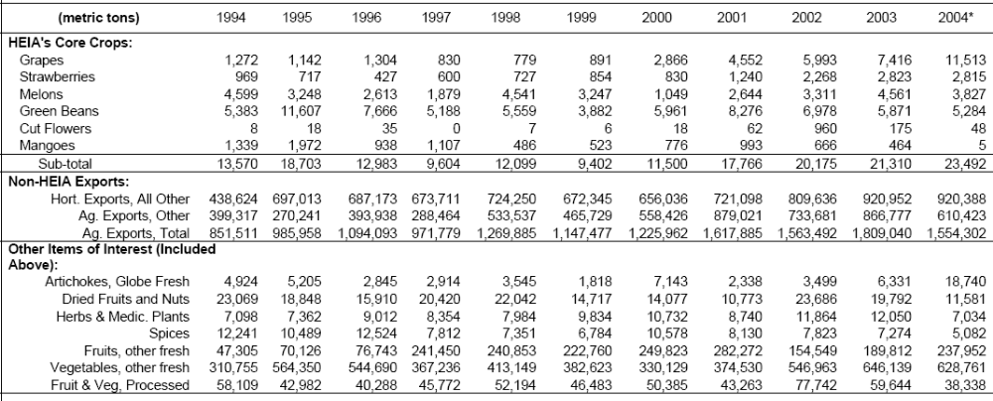
* 2004 data is January-July only
Based on CAPMAS data
Source: (Development Associates Inc., 2005)

- Exports of “HEIA Crops” Compared to Other Horticultural and Agricultural Exports, 1994-2004 (Quantity, Value and Average Price)
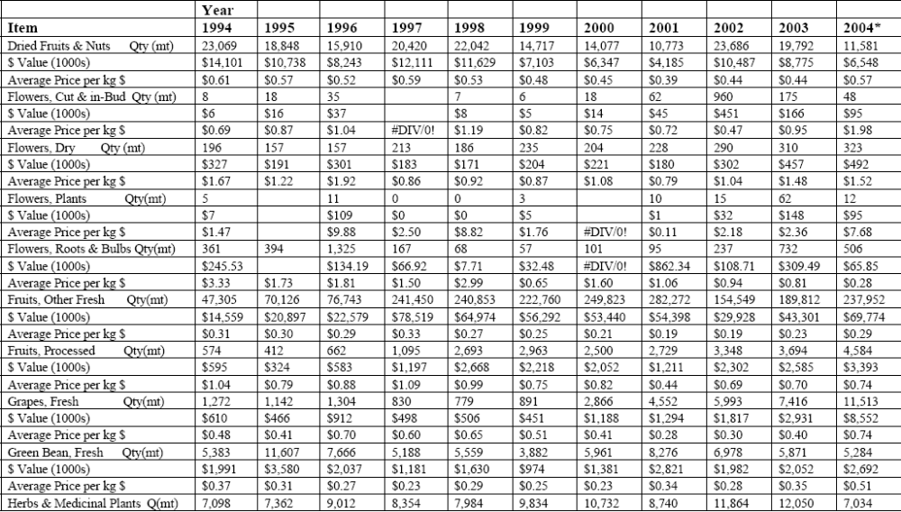
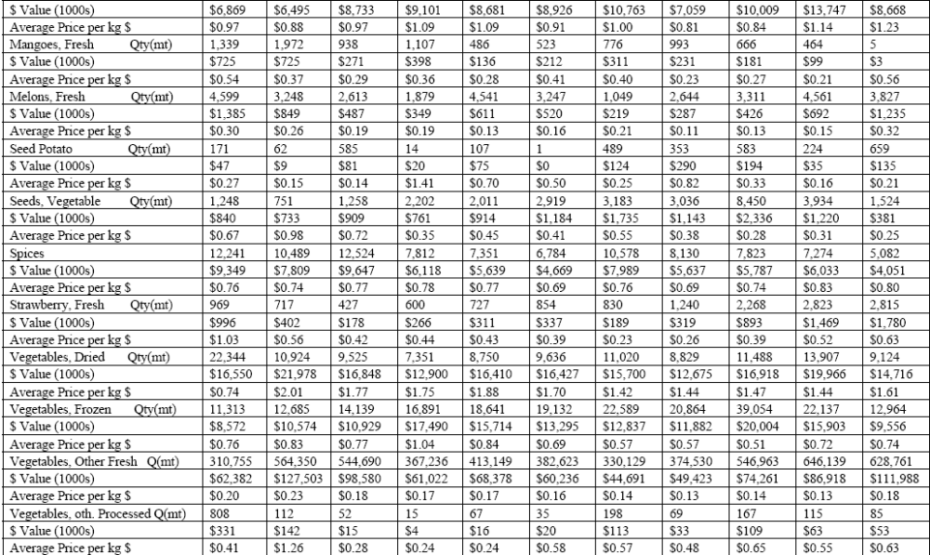
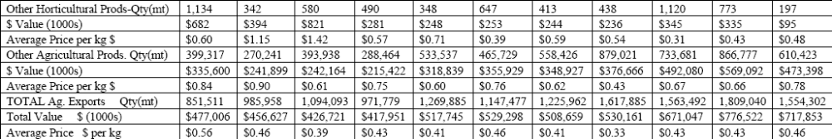
* 2004 data is January-July only
Based on CAPMAS data
Source: (Development Associates Inc., 2005)
Appendix 2: Agricultural Offers to Egypt, Preferences in 1997-2004 and EU/Egypt Association Agreement

- Agricultural Offers to Egypt, Preferences in 1977-2004 and Partnership Agreement
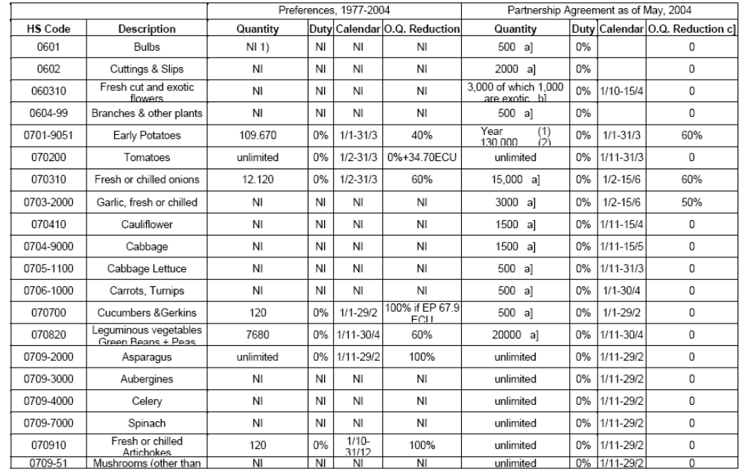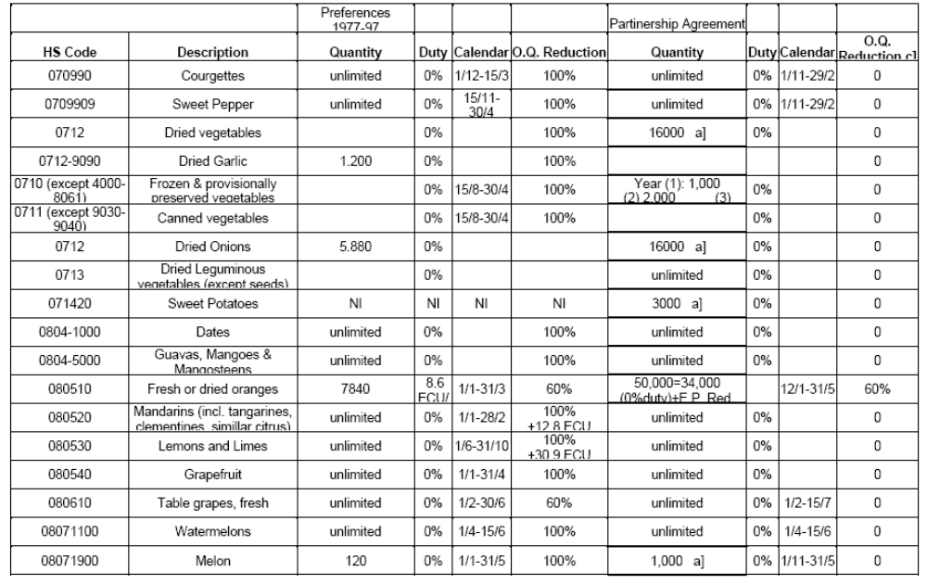
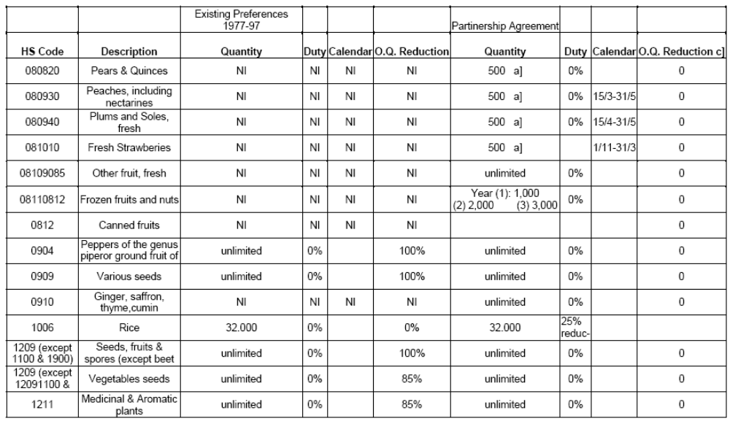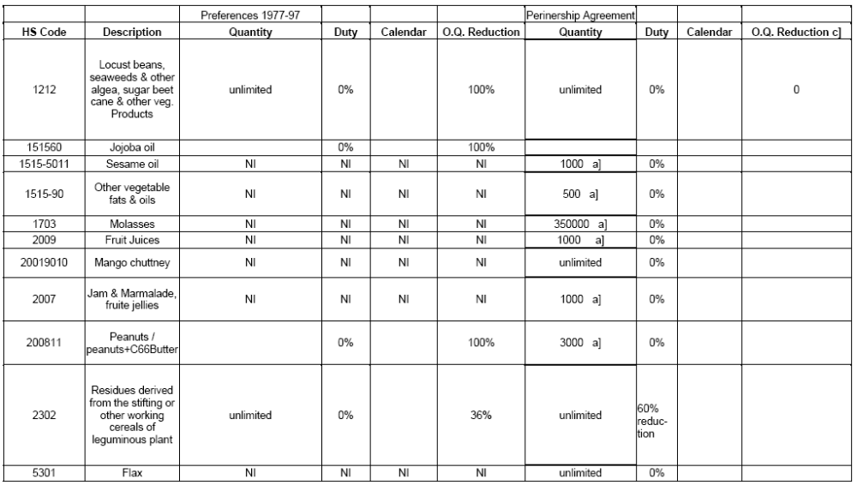
Source: EU/Egypt Association Agreement
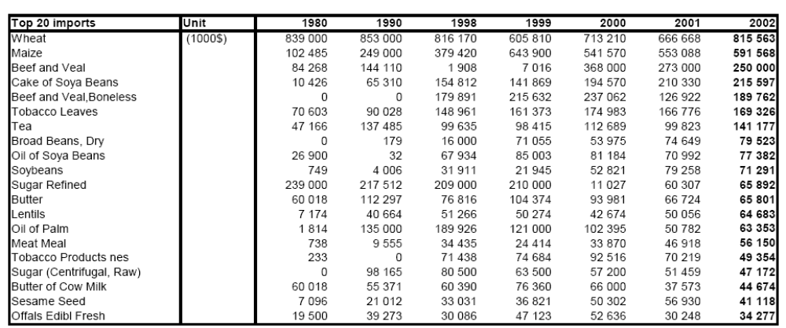

The Egyptian export products have no specificity as regards quality or being unique. The most important specificity is the period in which they are on the market. For example, the export of seedless table grapes and strawberries is rather successful, because Egypt's products are on the market when others are not. The exports of strawberries increased from 1,000 tons in 1999 to 11,000 tons in 2003. The existence of different production regions in Egypt enables the possibilities of different growing seasons as well as the choice of varieties.
http://ec.europa.eu/external_relations/egypt/aa/06_aaa_en.pdf
The ATUT project focused exclusively on improving exports of grape, strawberry, melon, mango, green bean and cut flowers to the regional and EU markets. It provided hands-on expatriate-led technical assistance and training to a group of 100 exporters, who accounted for 80-100% of exports of the selected products. Assistance was in the following areas: - management throughout the production and marketing chain; - access to and use of new cultivars that were disease resistant, met taste preferences in importer countries and better suited to market windows; - labor management in production and post-harvest; - water/irrigation management; - farming practices; and - cold chain and logistics. The project’s final evaluation in 2001 highlighted the following results: • Grape exports tripled in 3 years; • Strawberry and galia exports doubled; • Mango exports declined due to competition with other suppliers; and • Green bean exports increased by 30%. Though the dollar value was unchanged due to depreciation of the Euro, foreign currency earnings increased, employment increased by 8,000 jobs (of which 5,500 for women) in production/processing, and 22,000 jobs were created indirectly. Quality assurance and compliance with market requirements improved, thus safeguarding market share, and transport costs were reduced by US$1.7 million for grapes alone. As many as 100,000 small- and medium-scale farmers were exposed to new production techniques, with significant adoption rates. Female packing-house workers were trained to take on supervisory and management roles. There was useful institutional strengthening of HEIA (Lambert, 2002; Taylor et al., 2002).
Grant No. 263-G-00-99-00010-00 became effective on 12-21-98. The original amount was US$ 350,000, plus LE 340,000 designated to purchase tickets for overseas study travel. The grant amounts were augmented in a series of modifications, with the total amount reaching $4.63 million and LE 1.3 million in Modification 7 of November 2002. Subsequent modifications extended the closing date of the grant to September 30, 2004, without additional funding.
Initially, HEIA carried on with technical assistance and training activities that had been started by the Agriculture Technology Utilization and Transfer (ATUT) Project (1996-2002). It has since received multiple types of support from the Development Training II (DT2) project and several components of the Growth through Globalization (GTG) project. HEIA has also collaborated with the component activities of the Agricultural Exports and Rural Incomes (AERI) project.
Law N°94-37 of the 24th of February 1994, modifying the decree-law N° 70-1 3 of the 16th of October 1970 bringing reorganization of the ONH and ratified by the law n°70-53 of the 20th of November 1970.
Tunisia olive oil exports to the EU account for 10% of total imports and 60% of imports from Third countries. These imports are governed by regulatory measures fixing the tariffs in normal and in preferential regimes, and the standards of quality and merchandising within the framework of the olive oil and table olives Common Market Organization. These regulatory grant Third countries some tariff preferences on a quantity fixed by the commission (quota) and a total exoneration in inward-processing arrangements. They limit, however, the imports coming from these countries in normal regime that supports elevated tariffs.
http://europa.eu.int/comm/taxation_customs/dds/cgi-bin/tarchap?Lang=FR
COUNCIL REGULATION (EC) No 865/2004 of 29.4.2004 on the common organisation of the market in olive oil and table olives and amending Regulation (EEC) No 827/68. http://eur-lex.europa.eu/LexUriServ/LexUriServ.do?uri=OJ:L:2004:161:0097:0127:EN:PDF
COUNCIL REGULATION (EC) No 1782/2003 of 29 September 2003 establishing common rules for direct support schemes under the common agricultural policy and establishing certain support schemes for farmers and amending Regulations (EEC) No 2019/93, (EC) No 1452/2001, (EC) No 1453/2001, (EC) No 1454/2001, (EC) 1868/94, (EC) No 1251/1999, (EC) No 1254/1999, (EC) No 1673/2000, (EEC) No 2358/71 and (EC) No 2529/2001. http://eur-lex.europa.eu/LexUriServ/LexUriServ.do?uri=OJ:L:2003:270:0001:0069:EN:PDF
Decree n° 2005-2177 of the 9th of August 2005, Official Journal of the Tunisian Republic, 16th of August, 2005.
Decree n° 2006-2095 of the 24th of July 2006, Official Journal of the Tunisian Republic, 4th of August, 2006.
Program 11 - Projects 1,2,3,4,5
A comparative study (Batikhi 2001) proved that one cubic meter of water generates one US dollar when irrigating tomato while it generates 4-6 US$ when used to produce herbs such as oregano.
0.222 m ha are under rainfed cultivation and 0.083 m ha are under irrigation, the rest of the area is either left as fallow or not planted due to lack of water.
It is estimated that, by 2025, water supplied will exceed available renewable resources by 33 per cent (IFAD, 2007)
The development objective of the Horticultural Exports Promotion and Technology Transfer for Jordan is to improve horticultural export marketing by pilot testing: a) a system of outgrower farming between large and small/medium scale farmers (henceforth called outgrowers; and b) the building of the technological capacity of farmers, especially the outgrowers. There are four project components. The first component finances the creation of a specialized department in the Jordan Export Development and Commercial Centers Corporation (JEDCO) focusing solely on the promotion of horticultural exports. It also provides limited support to the Agricultural Marketing Department (AMD) in its role on collecting and relaying market prices to farmers, collecting statistics on production and export volumes, lobbying for export-friendly policies, and regulatory functions. The second component finances adaptive technology development and transfer, capacity building for small and medium scale farmers, and technology transfer specialists. The third component supports quality testing and certification of export produce. The fourth component funds the project coordination unit.
http://eur-lex.europa.eu/LexUriServ/LexUriServ.do?uri=OJ:L:2002:129:0001:0002:EN:PDF
http://trade.ec.europa.eu/doclib/docs/2007/october/tradoc_136441.pdf
Fresh herbs are often categorized as vegetables in trade statistic, leading to their underestimation. Fresh herbs are often not disaggregated to the larger variety of plants being grown and marketed.
http://www.ncartt.gov.jo/
http://www.mhplants.gov.jo/default.htm
http://www.fas.usda.gov/htp/Hort_Circular/2001/01-12/Stats/hazelnut.pdf
¹The 1st Standard Region is the traditional region composed of Artvin, Trabzon, Giresun and Ordu provinces (the eastern Black Sea Region), on hills and slopes where ecology generally does not allow economic production of other crops. The 2nd Standard Region covers the western part of the Black Sea Region and inland to more fertile and flatter lowlands of the provinces of Samsun, Sinop, Kastamonu, Zonguldak, Bolu, Düzce, Sakarya and Kocaeli
¹The 1st Standard Region is the traditional region composed of Artvin, Trabzon, Giresun and Ordu provinces (the eastern Black Sea Region), on hills and slopes where ecology generally does not allow economic production of other crops. The 2nd Standard Region covers the western part of the Black Sea Region and inland to more fertile and flatter lowlands of the provinces of Samsun, Sinop, Kastamonu, Zonguldak, Bolu, Düzce, Sakarya and Kocaeli
http://www.eacce.org.ma/default.asp
. Another source2 estimates that value-added per cubic meter of water from vegetable cultivation is US$0.37, rising to US$0.75 for fruit cultivation, and that these figures can be increased by over 107 percent and 48 percent, respectively, by the adoption of high-efficiency
The quota increased was due to the fact that during the 1995–2002 period, exports exceeded the quota level without affecting the European markets as well as the concession made by the Moroccan government on wheat imports (Aloui & Kenny, 2005)
The EU uses an entry price system for the more sensitive products. This system includes a severe tariff penalty if the item entry price is below a stipulated threshold. The effect is the imposing of a minimum price at which products enter the EU and compete with EU domestic products. The trigger price (minimum entry price) varies not only by product but also with the season. The minimum entry price system applies to 15 products: tomatoes, cucumbers, artichokes, courgettes, oranges, mandarins, clementines, lemons, apples, pears, grapes, apricots, cherries, peaches, plums, and orange and grape juice. While these 15 products represent a small share of the fruit and vegetable tariff lines, they represent a large share of the value (70%) of EU fruit and vegetable production. The value share is 82% for Italy, 80% for Greece, 72% for Spain, and 76% for France. These products are clearly important in certain production areas in these southern European countries. They also represent almost half of the value of European fruit and vegetable consumption and are the subject of much of the intra-EU trade in fruits and vegetables. The two largest sources of imports of these goods are the Mediterranean countries (27%) and South America (29%). In addition to the minimum import price, these commodities also have import windows. Often there are two windows – one during which a considerable potential for competition between imports and EU production is feared and another during which the competition with domestic production is considered to be minimal. During the competitive window, the minimum import price may be different, as it is not necessarily the same throughout the year. For some products, conditions may change several times a year, as often as monthly in some cases. (Jacquet et al., 2007)
Moroccan tomatoes enter the European market at a price lower than that of the other exporting countries. Production cost estimates (around €55 per 100 kg, that is to say fairly close to the import price level (€46 per 100 kg from January to April) suggest that abolishing the entry price would not necessarily result in a fall in the price of the Moroccan tomatoes sold on the European market (this reasoning could explain the little interest shown by Moroccan negotiators in requesting the lowering or abolition of the entry price; they find that this ensures payment for their production). The case is very different for Turkey and the other Mediterranean exporters of tomato to the EU. Indeed, they cannot export at a price below the MFN entry price (around €80 Euros per 100 kg from January to June). Our estimates show that the Turkish tomato production price is lower than this. Hence, the abolition or reduction of the entry price could result in an increase in Turkey's tomato exports, as these now go to other destinations (the Balkans and Saudi Arabia) as they compete on the EU market with tomatoes exported from Morocco and tomatoes produced by the EU. (Jacquet et al., 2007)
http://www.eacce.org.ma

